UNITED STATES
SECURITIES AND EXCHANGE COMMISSION
WASHINGTON, D.C. 20549

FORM 8-K

CURRENT REPORT
Pursuant to Section 13 or 15(d) of the Securities Exchange Act of 1934
Date of Report (Date of earliest event reported): September 09, 2026

Pyxis Oncology, Inc.
(Exact name of Registrant as Specified in Its Charter)

Delaware |  |  | 001-40881 | 83-1160910
(State or Other Jurisdiction  of Incorporation) |  |  | (Commission File Number) | (IRS Employer  Identification No.)
321 Harrison Avenue
Boston, Massachusetts |  |  |  | 02118
(Address of Principal Executive Offices) |  |  |  | (Zip Code)

Registrant’s Telephone Number, Including Area Code: (617) 453-3596

(Former Name or Former Address, if Changed Since Last Report)

Check the appropriate box below if the Form 8-K filing is intended to simultaneously satisfy the filing obligation of the registrant under any of the following provisions:
☐Written communications pursuant to Rule 425 under the Securities Act (17 CFR 230.425)
☐Soliciting material pursuant to Rule 14a-12 under the Exchange Act (17 CFR 240.14a-12)
☐Pre-commencement communications pursuant to Rule 14d-2(b) under the Exchange Act (17 CFR 240.14d-2(b))
☐Pre-commencement communications pursuant to Rule 13e-4(c) under the Exchange Act (17 CFR 240.13e-4(c))
Securities registered pursuant to Section 12(b) of the Act:
Title of each class |  | Trading  Symbol(s) |  | Name of each exchange on which registered
Common Stock, par value $0.001 per share |  | PYXS |  | The Nasdaq Global Select Market
Indicate by check mark whether the registrant is an emerging growth company as defined in Rule 405 of the Securities Act of 1933 (§ 230.405 of this chapter) or Rule 12b-2 of the Securities Exchange Act of 1934 (§ 240.12b-2 of this chapter).
Emerging growth company ☒
If an emerging growth company, indicate by check mark if the registrant has elected not to use the extended transition period for complying with any new or revised financial accounting standards provided pursuant to Section 13(a) of the Exchange Act. ☒

Item 7.01 Regulation FD Disclosure.
On September 9, 2026, Pyxis Oncology, Inc. (the “Company”) provided a corporate update and issued a press release announcing updated data from its ongoing global Phase 1 monotherapy study of micvotabart pelidotin (MICVO) in patients with second-line and beyond recurrent/metastatic head and neck squamous cell carcinoma. A copy of the press release is attached as Exhibit 99.1 and the corporate presentation is attached as Exhibit 99.2 to this Current Report on Form 8-K.
The information furnished under Item 7.01, including Exhibit 99.1 and Exhibit 99.2, shall not be deemed “filed” for purposes of Section 18 of the Securities Exchange Act of 1934, as amended (the “Exchange Act”), or otherwise subject to the liabilities of that section, nor shall it be deemed incorporated by reference in any filing under the Securities Act of 1933, as amended, or the Exchange Act, except as expressly set forth by specific reference in such a filing.
Item 8.01 Other Events.
The Company today announced updated data from its ongoing global Phase 1 monotherapy study evaluating micvotabart pelidotin (MICVO) in patients with second-line and beyond (2L+) recurrent/metastatic head and neck squamous cell carcinoma (R/M HNSCC). The cutoff date for all data reported below is August 18, 2026.
Demographics
Table 1: Patient Demographics and Disease Characteristics – 5.4 mg/kg Dose Cap Population (N=35)
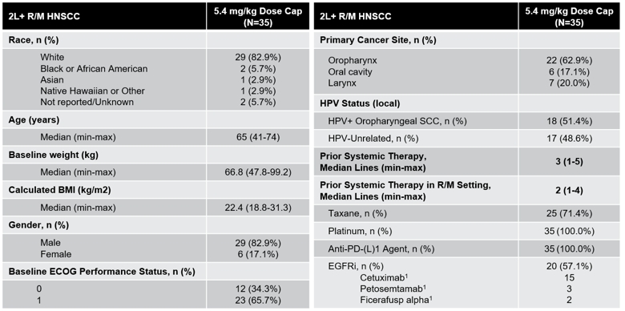
Data as of 18-Aug-2026
1. cetuximab: Eli Lilly and Company & Merck KGaA; petosemtamab: Genmab A/S; ficerafusp alpha: Bicara Therapeutics
Abbreviations: HPV: human papillomavirus; SCC: squamous cell carcinoma; EGFR: epidermal growth factor receptor; IO: immuno-oncology; ECOG: Eastern Cooperative Oncology Group; BMI: body mass index; PR: partial response; N/n: number of patients.

Efficacy Data
Table 2: Efficacy Data Summary – 5.4 mg/kg Dose Cap Efficacy-Evaluable Population (N=33)
Efficacy Measure | 5.4 mg/kg Dose Cap  (N=33)
Confirmed objective response rate (cORR), % (n/N) | 36% (12/33)
Disease control rate (DCR), % (n/N) | 94% (31/33)
Responders achieving response by the first scan at six weeks, % | 75%
Responders achieving >50% tumor reduction from baseline*, % | 83%
Median progression-free survival (mPFS), months, (95% CI) | 6.2 (4.8 - 8.8)
12-month overall survival (OS) probability, %, (95% CI) | 79% (58.1, 90.3)
Median overall survival (OS), months | NR (NR-NR)
Data as of 18-Aug-2026
*Per RECIST v1.1
Abbreviations: n/N: number of patients.

Table 3: Efficacy Data Across Key Patient Subgroups
Patient Subgroup | N | 5.4 mg/kg Dose Cap  Confirmed ORR, % | 5.4 mg/kg Dose Cap  Median PFS, months
HPV Status
HPV+ oropharyngeal | 17 | 35% | 6.2
HPV-unrelated | 16 | 38% | 5.9
Prior EGFRi
Yes | 18 | 28% | 5.0
No | 15 | 47% | 8.8
Prior Novel EGFRi*
Yes | 5 | 40% | 5.8
Prior Taxane
Yes | 23 | 35% | 6.2
No | 10 | 40% | 4.9
Data as of 18-Aug-2026
*Prior novel EGFRi subgroup is a subset of patients with prior EGFRi treatment.
Abbreviations: HPV: human papillomavirus; ORR: objective response rate; EGFRi: EGFR inhibitor; n/N: number of patients.

Safety Data
No new safety signals were observed with MICVO. The tolerability data was consistent with that of other ADCs with auristatin payloads and was generally manageable. Adverse events of interest, including peripheral neuropathy, generally occurred after patients had received evidence of benefit, and after prolonged duration of treatment.

Table 4: Safety Data Summary – 5.4 mg/kg Dose Cap Population (N=35)
TRAEs | 5.4 mg/kg with Dose Cap  (N=35)
Treatment duration – median days (range) | 120 (21-470)
All TRAEs, n (%) | 32 (91.4%)
TRAEs of CTCAE Grade ≥ 3, n (%) | 19 (54.3%)
Non-Hematologic TRAEs of CTCAE Grade ≥ 3, n (%) | 15 (42.9%)
Serious TRAEs, n (%) | 5 (14.3%)
TRAEs leading to treatment discontinuation*, n (%) | 5 (14.3%)
TRAEs leading to treatment discontinuation days, median (min-max) | 162 (104-212)
TRAEs leading to dose reduction, n (%) | 14 (40.0%)
Treatment related deaths (Grade 5) | 0
ADC Payload TRAEs of Interest | 5.4 mg/kg with Dose Cap  (N=35)
 | Gr1/2 | Gr3
Cutaneous, n (%) | 17 (48.6%) | 2 (5.7%)
Peripheral Neuropathy, n (%) | 14 (40.0%) | 6 (17.1%)
Peripheral Neuropathy days to onset, median (min-max) | 82 (3-157) | 166 (85-197)
Ocular, n (%) | 10 (28.6%) | 2 (5.7%)
Pneumonitis, n (%) | 4 (11.4%) | 0
Data as of 18-Aug-2026
*TRAEs leading to discontinuation, N=1 Ocular, N=1 Muscle Weakness, N=3 Peripheral Neuropathy
Abbreviations: ADC: antibody-drug conjugate; TRAE: treatment-related adverse event; CTCAE: Common Terminology Criteria for Adverse Events; Gr: grade; N: number of patients.

This Current Report on Form 8-K contains forward-looking statements for the purposes of the safe harbor provisions under the Private Securities Litigation Reform Act of 1995 and other federal securities laws. All statements other than statements of historical facts contained in this Form 8-K, including without limitation statements regarding the Company’s plans to develop, manufacture and commercialize its product candidate, including micvotabart pelidotin (‘MICVO’); preliminary data, timing and progress of the Company’s ongoing clinical trials; the expected results of the Company’s clinical trials; the ability of preliminary, initial and topline clinical data to de-risk MICVO and be confirmed with clinical trial progression, including the safety, tolerability, and potential efficacy of MICVO; the potential differentiation, advantage or effectiveness of MICVO compared to other approved products or products in development; the dosage and treatment potential of MICVO; the size and future of the market; the plans and objectives of management, and the future results of operations and financial position of the Company, are forward-looking statements. These statements are neither promises nor guarantees, but are statements that involve known and unknown risks, uncertainties and other important factors that are in some cases beyond the Company’s control that may cause actual results, performance or achievements to be materially different from any future results, performance or achievements expressed or implied by the forward-looking statements, including, but not limited to, the following: the risks inherent in drug research and development, the Company’s projected cash runway and potential needs for additional funding; the lengthy, expensive, and uncertain process of clinical drug development, including potential delays in or failure to obtain regulatory approvals; the Company’s reliance on third parties and collaborators to conduct clinical trials, manufacture its product candidate, and develop and commercialize its product candidate; and the Company’s ability to compete successfully against other drug candidate. Accordingly, investors should not rely upon forward-looking statements as predictions of future events. Except as required by applicable law, the Company undertakes no obligation to update publicly or revise any forward-looking statements contained herein, whether as a result of any new information, future events, changed circumstances or otherwise.

Item 9.01 Financial Statements and Exhibits.
(d) Exhibits
Exhibit No. |  | Description
99.1 |  | Press Release dated September 9, 2026.
99.2 |  | Presentation dated September 9, 2026.
104 |  | Cover Page Interactive Data File (embedded within the Inline XBRL document)

SIGNATURES
Pursuant to the requirements of the Securities Exchange Act of 1934, the registrant has duly caused this report to be signed on its behalf by the undersigned thereunto duly authorized.
 |  |  | Pyxis Oncology, Inc.
Date: | September 09, 2026 | By: | /s/ Jitendra Wadhane
Jitendra Wadhane
Principal Financial and Accounting Officer


Exhibit 99.1

Pyxis Oncology Announces Positive Updated Data from Phase 1 Monotherapy Study of Micvotabart Pelidotin (MICVO) in Second-Line and Beyond Recurrent/Metastatic Head and Neck Squamous Cell Carcinoma (2L+ R/M HNSCC)

MICVO demonstrated rapid and deep responses, with a 36% confirmed objective response rate (cORR) and 94% disease control rate (DCR), with clinical activity observed across HPV status and prior-treatment subgroups

Substantial survival outcomes include median progression-free survival (mPFS) of 6.2 months and 12-month overall survival (OS) probability of 79%, with clinical activity observed across HPV status and prior-treatment subgroups

No new safety signals observed; tolerability profile expected & consistent
with prolonged auristatin exposure; dose capping reduced frequency and severity of adverse events in high body weight patients

MICVO potentially addresses significant unmet need in 2L+ R/M HNSCC, where evolving first-line treatment landscape is expected to create a demand for novel non-EGFRi treatment options

Data support advancement of MICVO into a pivotal program in 2L+ R/M HNSCC, with initiation of Phase 3 Headliner trial planned for mid-2027

Company to host webcast today at 7:30 a.m. ET

BOSTON, September 9, 2026 (GLOBE NEWSWIRE) — Pyxis Oncology, Inc. (Nasdaq: PYXS), a clinical-stage company developing next-generation therapeutics for difficult-to-treat cancers, today announced positive updated data as of the August 18, 2026 data cutoff date from its ongoing global Phase 1 monotherapy study evaluating micvotabart pelidotin (MICVO) in patients with second-line and beyond (2L+) recurrent/metastatic head and neck squamous cell carcinoma (R/M HNSCC).

The updated results represent a population (N=33 efficacy evaluable) dosed at 5.4 mg/kg intravenously once every three weeks with a dose equivalent to or below a dose cap. These data demonstrated rapid and deep responses, with a 36% confirmed objective response rate (cORR) and 94% disease control rate (DCR). Median progression-free survival (mPFS) was 6.2 months, and the 12-month overall survival (OS) probability was 79% while median OS (mOS) has not yet been reached. Clinical activity was observed across key patient subgroups, including HPV status and prior treatment. No new safety signals were observed (N=35 safety evaluable), and dose capping reduced the frequency and severity of adverse events in high body weight patients.

MICVO, the company’s lead program, is a first-in-concept antibody-drug conjugate (ADC) targeting extradomain-B of fibronectin (EDB+FN), a non-cellular structural component of the tumor extracellular matrix. MICVO’s differentiated, non-EGFR targeting mechanism of action positions it to potentially serve a significant patient population and address unmet need in 2L+ R/M HNSCC as the first-line treatment landscape continues to evolve.

“There remains significant need for effective treatment options for patients with recurrent or metastatic head and neck cancer who progress following first-line therapy, particularly as the front-line treatment landscape continues to evolve,” said Alan L. Ho, M.D., Ph.D., Chief, Head and Neck Oncology Service and Attending Medical Oncologist, Memorial Sloan Kettering Cancer Center. “In this heavily pretreated population, these results demonstrated rapid and deep responses, along with progression-free survival and preliminary overall survival results that warrant further evaluation.”

“These updated data reinforce our conviction in MICVO’s potential to become an important treatment option for patients with cancer,” said Tom Civik, Chief Executive Officer and Chairman of Pyxis Oncology. “We are particularly encouraged by the combination of rapid and deep responses, substantial survival outcomes and a manageable safety profile. The data also provide important validation of our dose capping strategy, which was intended to maintain clinical activity while mitigating the risk of safety events. Based on feedback from the FDA and EMA on the design of our pivotal Phase 3 study, Headliner, we believe MICVO is well positioned for success in a randomized trial, which we plan to initiate in mid-2027.”

Updated MICVO Phase 1 Monotherapy Trial Results as of August 18, 2026

Demographics

Table 1: Patient Demographics and Disease Characteristics – 5.4 mg/kg Dose Cap Population (N=35)

Data as of 18-Aug-2026
1. cetuximab: Eli Lilly and Company & Merck KGaA; petosemtamab: Genmab A/S; ficerafusp alpha: Bicara Therapeutics
Abbreviations: HPV: human papillomavirus; SCC: squamous cell carcinoma; EGFR: epidermal growth factor receptor; IO: immuno-oncology; ECOG: Eastern Cooperative Oncology Group; BMI: body mass index; PR: partial response; N/n: number of patients.

Efficacy Data

Table 2: Efficacy Data Summary – 5.4 mg/kg Dose Cap Efficacy-Evaluable Population (N=33)
Efficacy Measure | 5.4 mg/kg Dose Cap  (N=33)
Confirmed objective response rate (cORR), % (n/N) | 36% (12/33)
Disease control rate (DCR), % (n/N) | 94% (31/33)
Responders achieving response by the first scan at six weeks, % | 75%
Responders achieving >50% tumor reduction from baseline*, % | 83%
Median progression-free survival (mPFS), months, (95% CI) | 6.2 (4.8-8.8)
12-month overall survival (OS) probability, %, (95% CI) | 79% (58.1,90.3)
Median overall survival (OS), months | NR (NR-NR)
Data as of 18-Aug-2026
*Per RECIST v1.1
Abbreviations: n/N: number of patients.

Table 3: Efficacy Data Across Key Patient Subgroups
Patient Subgroup | N | 5.4 mg/kg Dose Cap  Confirmed ORR, % | 5.4 mg/kg Dose Cap  Median PFS, months
HPV Status
HPV+ oropharyngeal | 17 | 35% | 6.2
HPV-unrelated | 16 | 38% | 5.9
Prior EGFRi
Yes | 18 | 28% | 5.0
No | 15 | 47% | 8.8
Prior Novel EGFRi*
Yes | 5 | 40% | 5.8
Prior Taxane
Yes | 23 | 35% | 6.2
No | 10 | 40% | 4.9
Data as of 18-Aug-2026
*Prior novel EGFRi subgroup is a subset of patients with prior EGFRi treatment.
Abbreviations: HPV: human papillomavirus; ORR: objective response rate; EGFRi: EGFR inhibitor; n/N: number of patients.

Safety Data
No new safety signals were observed with MICVO. The tolerability data was consistent with that of other ADCs with auristatin payloads and was generally manageable. Adverse events of interest, including peripheral neuropathy, generally occurred after patients had received evidence of benefit, and after prolonged duration of treatment.

Table 4: Safety Data Summary – 5.4 mg/kg Dose Cap Population (N=35)
TRAEs | 5.4 mg/kg with Dose Cap  (N=35)
Treatment duration – median days (range) | 120 (21-470)
All TRAEs, n (%) | 32 (91.4%)
TRAEs of CTCAE Grade ≥ 3, n (%) | 19 (54.3%)
Non-Hematologic TRAEs of CTCAE Grade ≥ 3, n (%) | 15 (42.9%)
Serious TRAEs, n (%) | 5 (14.3%)
TRAEs leading to treatment discontinuation*, n (%) | 5 (14.3%)
TRAEs leading to treatment discontinuation days, median (min-max) | 162 (104-212)
TRAEs leading to dose reduction, n (%) | 14 (40.0%)
Treatment related deaths (Grade 5) | 0
ADC Payload TRAEs of Interest | 5.4 mg/kg with Dose Cap  (N=35)
 | Gr1/2 | Gr3
Cutaneous, n (%) | 17 (48.6%) | 2 (5.7%)
Peripheral Neuropathy, n (%) | 14 (40.0%) | 6 (17.1%)
Peripheral Neuropathy days to onset, median (min-max) | 82 (3-151) | 166 (85-197)
Ocular, n (%) | 10 (28.6%) | 2 (5.7%)
Pneumonitis, n (%) | 4 (11.4%) | 0
Data as of 18-Aug-2026
*TRAEs leading to discontinuation, N=1 Ocular, N=1 Muscle Weakness, N=3 Peripheral Neuropathy
Abbreviations: ADC: antibody-drug conjugate; TRAE: treatment-related adverse event; CTCAE: Common Terminology Criteria for Adverse Events; Gr: grade; N: number of patients.

MICVO Next Steps

Monotherapy
Pyxis Oncology is advancing the clinical development of MICVO through Project Optimus, a U.S. Food and Drug Administration (FDA) initiative focused on dose optimization and dose selection in oncology drug development. An End of Phase 2 meeting with the FDA to align on dose selection is anticipated in the first quarter of 2027. Updated overall survival data from the MICVO monotherapy study are expected in the first half of 2027.

The Company has aligned with the feedback from the FDA and the European Medicines Agency (EMA) on the design of the planned pivotal Phase 3 monotherapy study of MICVO in patients with second- or third-line R/M HNSCC who have progressed following treatment with both a platinum-based therapy and an anti-PD-1 therapy. The randomized, open-label, 2-arm study will enroll approximately 500 patients who will be randomized 1:1 to receive MICVO or investigators’ choice of cetuximab, docetaxel, or methotrexate. The co-primary endpoints of the study will be overall response rate and overall survival. Pyxis Oncology plans to initiate the study in mid-2027 following alignment with the FDA on dose selection.

Combination with KEYTRUDA® (pembrolizumab)
Pyxis Oncology expects to report updated data from the ongoing Phase 1/2 combination dose escalation study of MICVO and Merck’s (known as MSD outside of the US and Canada) anti-PD-1 therapy KEYTRUDA® (pembrolizumab) for 1L R/M HNSCC patients in the fourth quarter of 2026. Preliminary positive results for the treatment of 1L/2L+ R/M HNSCC were shared in December 2025. Additional data evaluating initial durability and selection of the recommended Phase 3 dose (RP3D) for the 1L combination are expected in the second half of 2027.

Webcast Information
Pyxis Oncology will host a live webcast today at 7:30 a.m. Eastern Time. To participate in the live event, please register using this link. The event and accompanying slides can be accessed by visiting the investor relations section of the Company's website at https://ir.pyxisoncology.com. An archived webcast will be available on the Company's website following the event.

About the MICVO Phase 1 Monotherapy Trial
The ongoing Phase 1 monotherapy study of MICVO is a multi-part study. Part 1 was a dose escalation study across multiple doses and tumor types, with initial results shared in November 2024. Part 2 is a dose expansion study in 2L+ R/M HNSCC. Preliminary Phase 1 study results in 2L+ R/M HNSCC were shared in December 2025.

The dose expansion portion of the study includes two arms: post-platinum and anti-PD-(L)1 patients (Arm 1) and post-EGFR inhibitor and anti-PD-(L)1 patients (Arm 2). Target enrollment for each arm was approximately 20 patients, and the Company completed target enrollment in the Phase 1 Part 2 monotherapy dose expansion study in the first quarter of 2026.

In December 2025, a dose cap was implemented for high body weight patients. Based on internal pharmacokinetic (PK) simulation modeling indicating that MICVO exposures with dose capping and adjusted ideal bodyweight (AIBW) dosing are expected to be comparable, dose capping was prioritized due to its operational simplicity and speed of implementation. The updated results reported today focus on patients treated at 5.4 mg/kg Q3W with a dose cap.

About Micvotabart Pelidotin (MICVO)
Micvotabart pelidotin (MICVO, formerly PYX-201) is an antibody-drug conjugate (ADC) that uniquely targets extradomain-B of fibronectin (EDB+FN), a non-cellular structural component of the tumor extracellular matrix. MICVO is designed to generate a multi-pronged attack on difficult-to-treat cancers by directly killing cancer cells, reducing extra-cellular matrix density, inhibiting tumor angiogenesis and mobilizing an anti-tumor immune response.

MICVO received Fast Track Designation from the U.S. Food and Drug Administration for the treatment of adult patients with R/M HNSCC whose disease has progressed following treatment with platinum-based chemotherapy and an anti-PD-(L)-1 therapy.

About Pyxis Oncology, Inc.
Pyxis Oncology, Inc. is a clinical-stage biopharmaceutical company developing therapeutics for difficult-to-treat cancers. The Company’s lead candidate, micvotabart pelidotin (MICVO), is a first-in-concept antibody-drug conjugate (ADC) that targets extradomain-B of fibronectin (EDB+FN), a non-cellular structural component of the tumor extracellular matrix (ECM). EDB+FN is selectively overexpressed in the tumor microenvironment of a wide range of solid tumors and largely absent from normal adult tissues. MICVO is designed to treat solid tumors through a three-pronged mechanism of action: direct cancer cell killing, bystander effect and immunogenic cell death. MICVO is currently being evaluated as monotherapy in a Phase 1 clinical study in patients with recurrent and metastatic head and neck squamous cell carcinoma (R/M HNSCC) and in combination with Merck’s anti-PD-1 therapy, KEYTRUDA® (pembrolizumab) in a Phase 1/2 clinical study in patients with R/M HNSCC and other solid tumors. Pyxis Oncology is focused on advancing MICVO, with the goal of improving outcomes for patients living with R/M HNSCC and contributing to meaningful progress in cancer treatment.

To learn more, visit www.pyxisoncology.com or follow us on LinkedIn.

KEYTRUDA® is a registered trademark of Merck Sharp & Dohme LLC, a subsidiary of Merck & Co., Inc., Rahway, NJ, USA.

Forward-Looking Statements
This press release contains forward-looking statements for the purposes of the safe harbor provisions under the Private Securities Litigation Reform Act of 1995 and other federal securities laws. All statements other than statements of historical facts contained in this press release, including without limitation statements regarding the Company’s plans to develop, manufacture and commercialize its product candidate, including micvotabart pelidotin (‘MICVO’); preliminary data, timing and progress of the Company’s ongoing clinical trials; the expected results of the Company’s clinical trials; the ability of preliminary, initial and topline clinical data to de-risk MICVO and be confirmed with clinical trial progression, including the safety, tolerability, and potential efficacy of MICVO; the potential differentiation, advantage or effectiveness of MICVO compared to other approved products or products in development; the dosage and treatment potential of MICVO; the size and future of the market; the plans and objectives of management, and the future results of operations and financial position of the Company, are forward-looking statements. These statements are neither promises nor guarantees, but are statements that involve known and unknown risks, uncertainties and other important factors that are in some cases beyond the Company’s control that may cause actual results, performance or achievements to be materially different from any future results, performance or achievements expressed or implied by the forward-looking statements, including, but not limited to, the following: the risks inherent in drug research and development, the Company’s projected cash runway and potential needs for additional funding; the lengthy, expensive, and uncertain process of clinical drug development, including potential delays in or failure to obtain regulatory approvals; the Company’s reliance on third parties and collaborators to conduct clinical trials, manufacture its product candidate, and develop and commercialize its product candidate; and the Company’s ability to compete successfully against other drug candidate. Accordingly, investors should not rely upon forward-looking statements as predictions of future events. Except as required by applicable law, the Company undertakes no obligation to update publicly or revise any forward-looking statements contained herein, whether as a result of any new information, future events, changed circumstances or otherwise. Additionally, investors should read risk factors in the section titled “Risk Factors” set forth in Part II, Item 1A. of the Company’s Quarterly Report on Form 10-Q filed on August 13, 2026, and the Company’s other filings, each of which is on file with the Securities and Exchange Commission.

Pyxis Oncology Contact
IR@pyxisoncology.com


Pyxis Oncology ?MICVO Clinical Update September 9, 2026 Exhibit 99.2

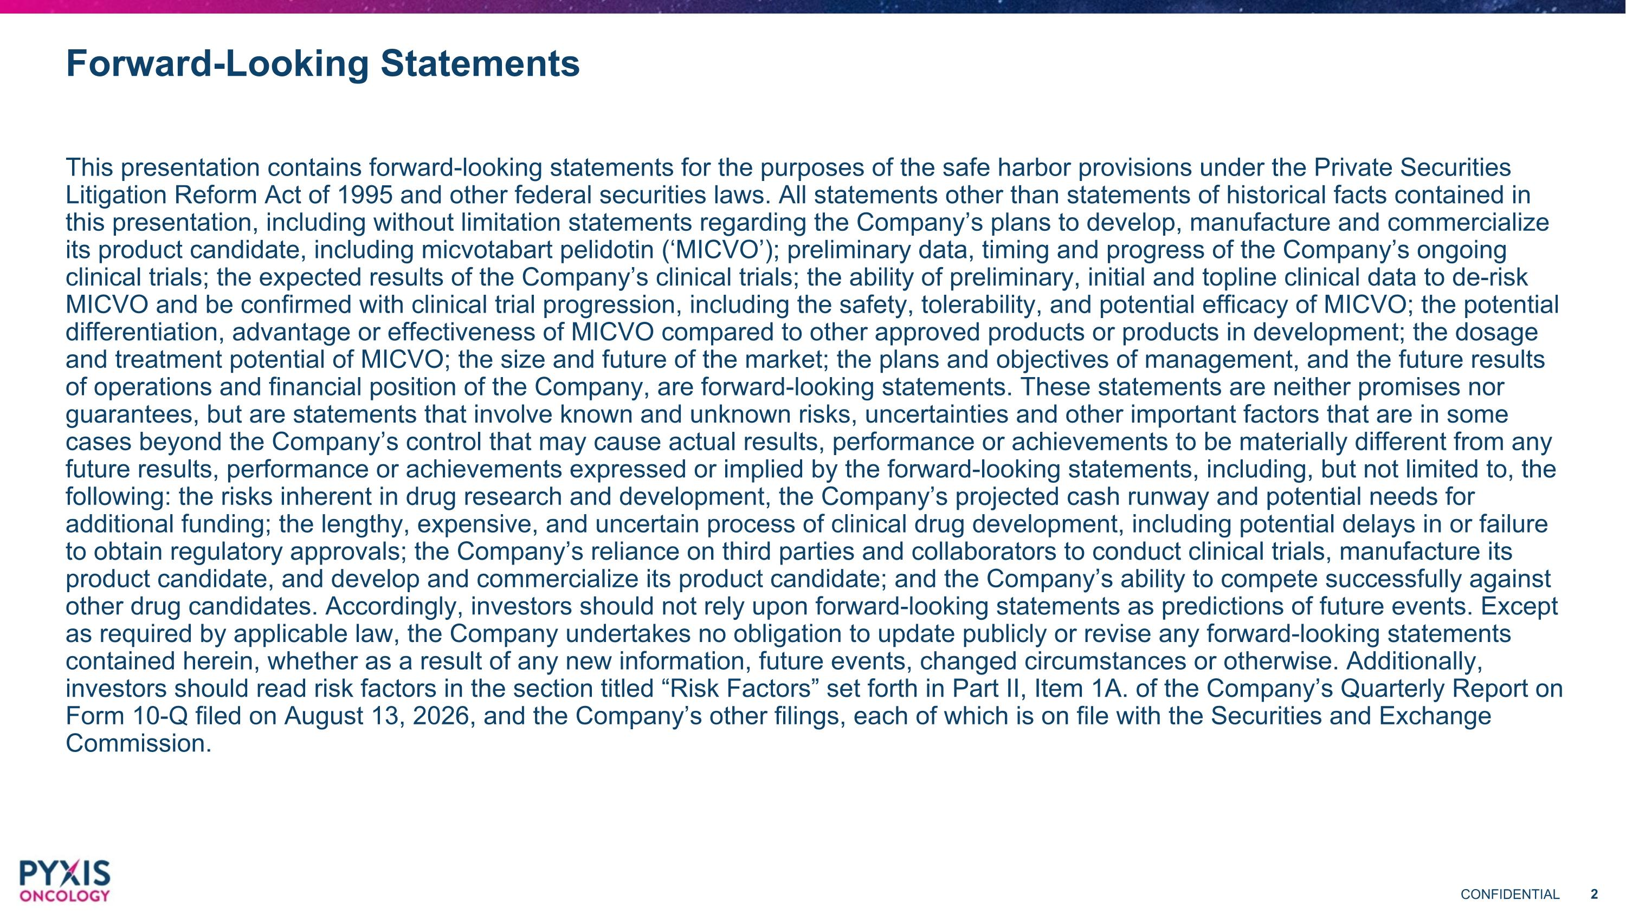
Forward-Looking Statements This presentation contains forward-looking statements for the purposes of the safe harbor provisions under the Private Securities Litigation Reform Act of 1995 and other federal securities laws. All statements other than statements of historical facts contained in this presentation, including without limitation statements regarding the Company’s plans to develop, manufacture and commercialize its product candidate, including micvotabart pelidotin (‘MICVO’); preliminary data, timing and progress of the Company’s ongoing clinical trials; the expected results of the Company’s clinical trials; the ability of preliminary, initial and topline clinical data to de-risk MICVO and be confirmed with clinical trial progression, including the safety, tolerability, and potential efficacy of MICVO; the potential differentiation, advantage or effectiveness of MICVO compared to other approved products or products in development; the dosage and treatment potential of MICVO; the size and future of the market; the plans and objectives of management, and the future results of operations and financial position of the Company, are forward-looking statements. These statements are neither promises nor guarantees, but are statements that involve known and unknown risks, uncertainties and other important factors that are in some cases beyond the Company’s control that may cause actual results, performance or achievements to be materially different from any future results, performance or achievements expressed or implied by the forward-looking statements, including, but not limited to, the following: the risks inherent in drug research and development, the Company’s projected cash runway and potential needs for additional funding; the lengthy, expensive, and uncertain process of clinical drug development, including potential delays in or failure to obtain regulatory approvals; the Company’s reliance on third parties and collaborators to conduct clinical trials, manufacture its product candidate, and develop and commercialize its product candidate; and the Company’s ability to compete successfully against other drug candidates. Accordingly, investors should not rely upon forward-looking statements as predictions of future events. Except as required by applicable law, the Company undertakes no obligation to update publicly or revise any forward-looking statements contained herein, whether as a result of any new information, future events, changed circumstances or otherwise. Additionally, investors should read risk factors in the section titled “Risk Factors” set forth in Part II, Item 1A. of the Company’s Quarterly Report on Form 10-Q filed on August 13, 2026, and the Company’s other filings, each of which is on file with the Securities and Exchange Commission.


Pyxis Oncology – Meet the Team Tom Dorney, MS, MBA SVP, Strategy & Financial Planning Tom Civik, MBA Chief Executive Officer Brian Freeman, MBA Chief Program Officer Marsha Crochiere, PhD VP, Head of Translational Medicine & Research Hongwei Wang, MD, PhD SVP, Head of ADC Development & Clinical Strategy


Alan L. Ho, MD, PhD Chief, Head and Neck Oncology Service and Attending Medical Oncologist, Memorial Sloan Kettering Cancer Center Alan L. Ho, MD, PhD, is Chief of the Head and Neck Oncology Service and an attending medical oncologist at Memorial Sloan Kettering Cancer Center. He specializes in the treatment of head and neck cancers, including thyroid, salivary gland, and head and neck squamous cell cancers. Dr. Ho is also a translational clinical researcher whose work focuses on developing innovative and personalized therapies for patients with head and neck malignancies.

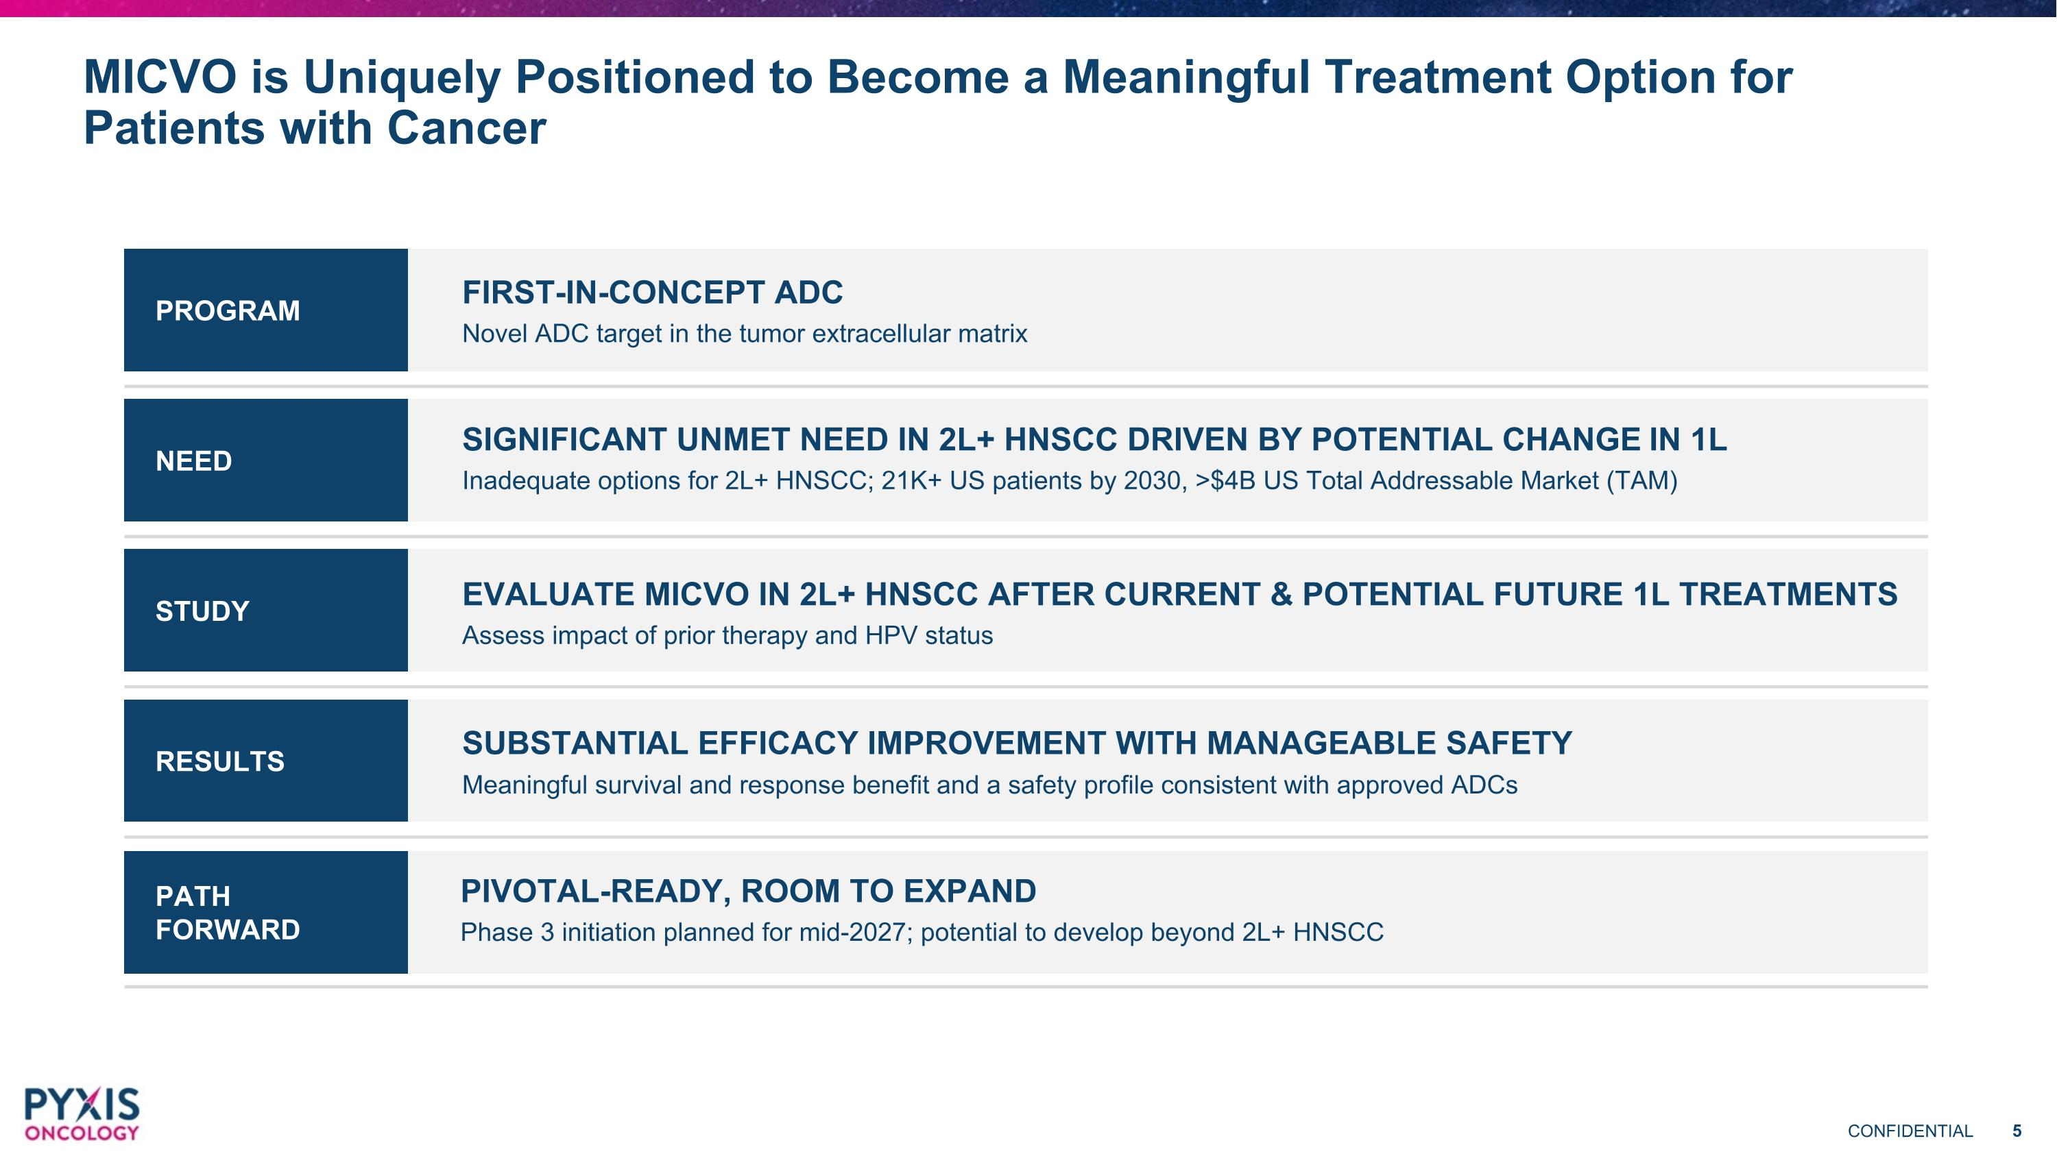
PATH FORWARD RESULTS STUDY NEED MICVO is Uniquely Positioned to Become a Meaningful Treatment Option for Patients with Cancer PROGRAM FIRST-IN-CONCEPT ADC Novel ADC target in the tumor extracellular matrix SIGNIFICANT UNMET NEED IN 2L+ HNSCC DRIVEN BY POTENTIAL CHANGE IN 1L Inadequate options for 2L+ HNSCC; 21K+ US patients by 2030, >$4B US Total Addressable Market (TAM) EVALUATE MICVO IN 2L+ HNSCC AFTER CURRENT & POTENTIAL FUTURE 1L TREATMENTS Assess impact of prior therapy and HPV status SUBSTANTIAL EFFICACY IMPROVEMENT WITH MANAGEABLE SAFETY Meaningful survival and response benefit and a safety profile consistent with approved ADCs PIVOTAL-READY, ROOM TO EXPAND Phase 3 initiation planned for mid-2027; potential to develop beyond 2L+ HNSCC

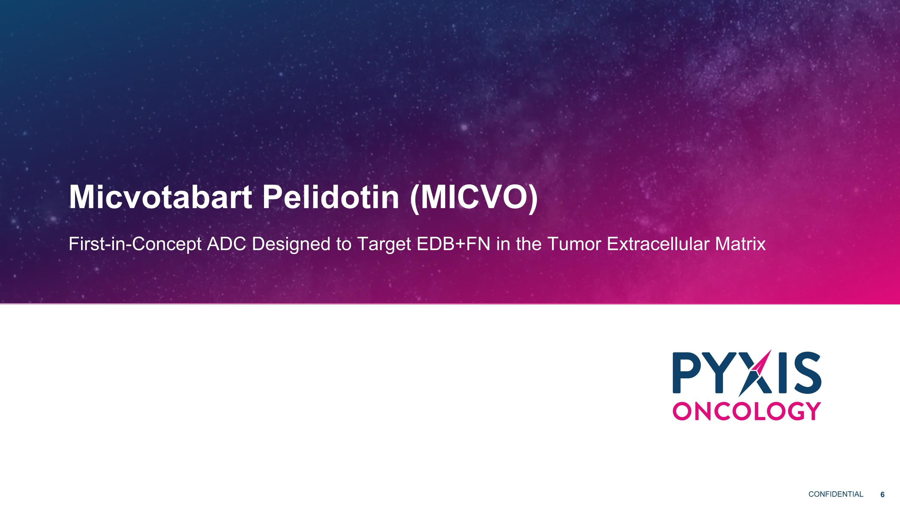
Micvotabart Pelidotin (MICVO) First-in-Concept ADC Designed to Target EDB+FN in the Tumor Extracellular Matrix

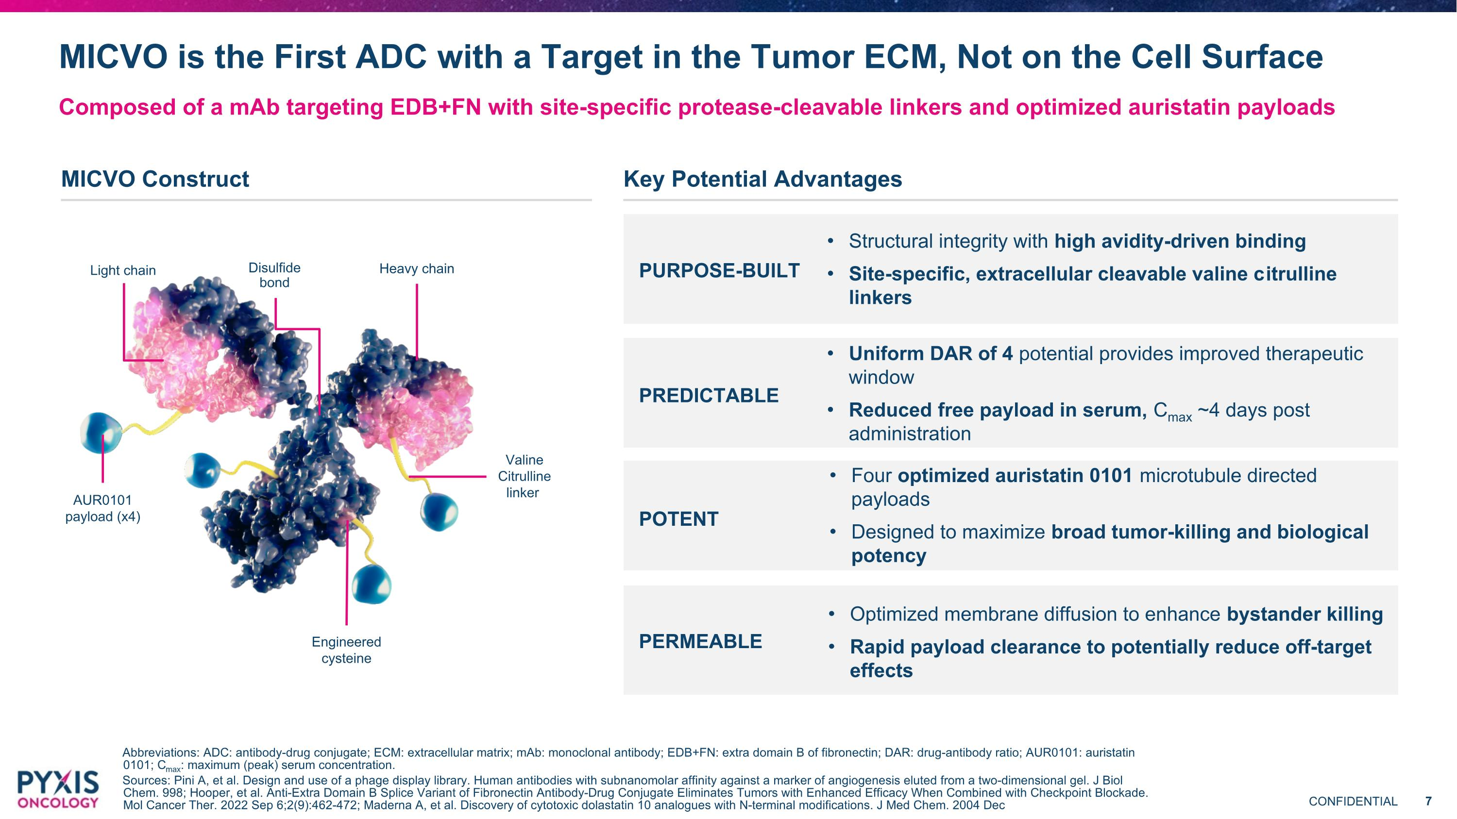
MICVO Construct MICVO is the First ADC with a Target in the Tumor ECM, Not on the Cell Surface Composed of a mAb targeting EDB+FN with site-specific protease-cleavable linkers and optimized auristatin payloads Abbreviations: ADC: antibody-drug conjugate; ECM: extracellular matrix; mAb: monoclonal antibody; EDB+FN: extra domain B of fibronectin; DAR: drug-antibody ratio; AUR0101: auristatin 0101; Cmax: maximum (peak) serum concentration. Sources: Pini A, et al. Design and use of a phage display library. Human antibodies with subnanomolar affinity against a marker of angiogenesis eluted from a two-dimensional gel. J Biol Chem. 998; Hooper, et al. Anti-Extra Domain B Splice Variant of Fibronectin Antibody-Drug Conjugate Eliminates Tumors with Enhanced Efficacy When Combined with Checkpoint Blockade. Mol Cancer Ther. 2022 Sep 6;2(9):462-472; Maderna A, et al. Discovery of cytotoxic dolastatin 10 analogues with N-terminal modifications. J Med Chem. 2004 Dec Structural integrity with high avidity-driven binding Site-specific, extracellular cleavable valine citrulline linkers Uniform DAR of 4 potential provides improved therapeutic window Reduced free payload in serum, Cmax ~4 days post administration Four optimized auristatin 0101 microtubule directed payloads Designed to maximize broad tumor-killing and biological potency PURPOSE-BUILT PREDICTABLE Optimized membrane diffusion to enhance bystander killing Rapid payload clearance to potentially reduce off-target effects POTENT PERMEABLE Key Potential Advantages AUR0101 payload (x4) Valine Citrulline linker Light chain Heavy chain Engineered cysteine Disulfide bond

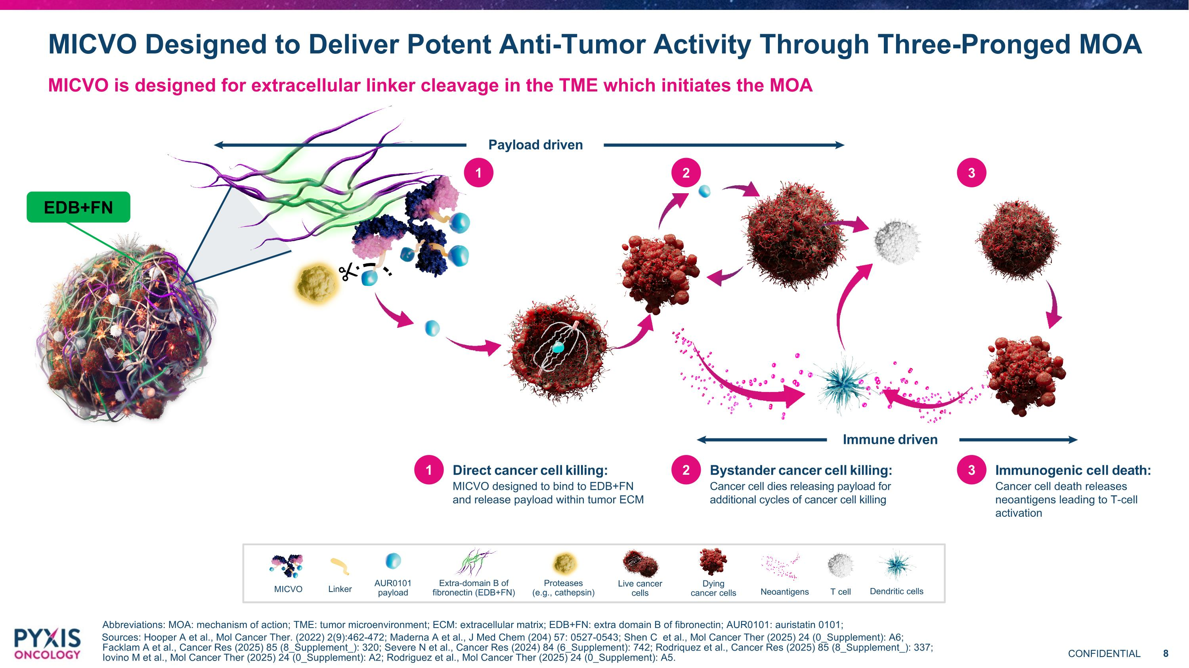
Direct cancer cell killing: MICVO designed to bind to EDB+FN and release payload within tumor ECM Immunogenic cell death: Cancer cell death releases neoantigens leading to T-cell activation Immune driven Payload driven Bystander cancer cell killing: Cancer cell dies releasing payload for additional cycles of cancer cell killing 1 2 3 1 2 3 MICVO Designed to Deliver Potent Anti-Tumor Activity Through Three-Pronged MOA MICVO is designed for extracellular linker cleavage in the TME which initiates the MOA MICVO Linker AUR0101 payload Extra-domain B of fibronectin (EDB+FN) Proteases ?(e.g., cathepsin) Live cancer cells Dying cancer cells Neoantigens T cell Dendritic cells EDB+FN Abbreviations: MOA: mechanism of action; TME: tumor microenvironment; ECM: extracellular matrix; EDB+FN: extra domain B of fibronectin; AUR0101: auristatin 0101; Sources: Hooper A et al., Mol Cancer Ther. (2022) 2(9):462-472; Maderna A et al., J Med Chem (204) 57: 0527-0543; Shen C et al., Mol Cancer Ther (2025) 24 (0_Supplement): A6; Facklam A et al., Cancer Res (2025) 85 (8_Supplement_): 320; Severe N et al., Cancer Res (2024) 84 (6_Supplement): 742; Rodriquez et al., Cancer Res (2025) 85 (8_Supplement_): 337; Iovino M et al., Mol Cancer Ther (2025) 24 (0_Supplement): A2; Rodriguez et al., Mol Cancer Ther (2025) 24 (0_Supplement): A5.

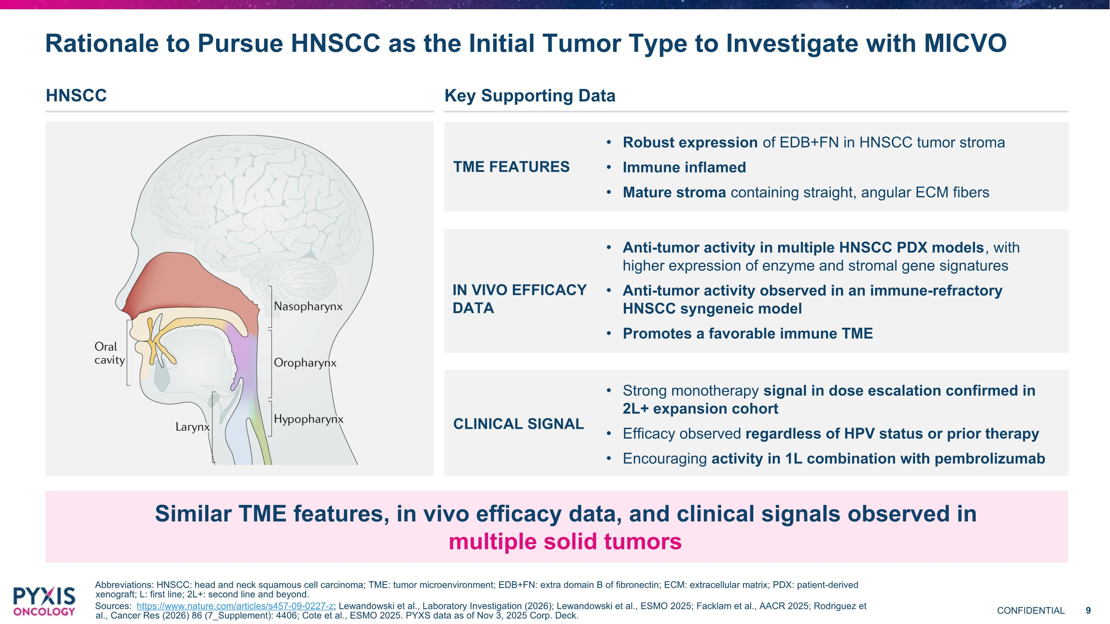
Similar TME features, in vivo efficacy data, and clinical signals observed in multiple solid tumors Rationale to Pursue HNSCC as the Initial Tumor Type to Investigate with MICVO Abbreviations: HNSCC: head and neck squamous cell carcinoma; TME: tumor microenvironment; EDB+FN: extra domain B of fibronectin; ECM: extracellular matrix; PDX: patient-derived xenograft; L: first line; 2L+: second line and beyond. Sources: https://www.nature.com/articles/s457-09-0227-z; Lewandowski et al., Laboratory Investigation (2026); Lewandowski et al., ESMO 2025; Facklam et al., AACR 2025; Rodriguez et al., Cancer Res (2026) 86 (7_Supplement): 4406; Cote et al., ESMO 2025. PYXS data as of Nov 3, 2025 Corp. Deck. Robust expression of EDB+FN in HNSCC tumor stroma Immune inflamed Mature stroma containing straight, angular ECM fibers TME FEATURES Anti-tumor activity in multiple HNSCC PDX models, with higher expression of enzyme and stromal gene signatures Anti-tumor activity observed in an immune-refractory HNSCC syngeneic model Promotes a favorable immune TME IN VIVO EFFICACY DATA Strong monotherapy signal in dose escalation confirmed in 2L+ expansion cohort Efficacy observed regardless of HPV status or prior therapy Encouraging activity in 1L combination with pembrolizumab CLINICAL SIGNAL HNSCC Key Supporting Data

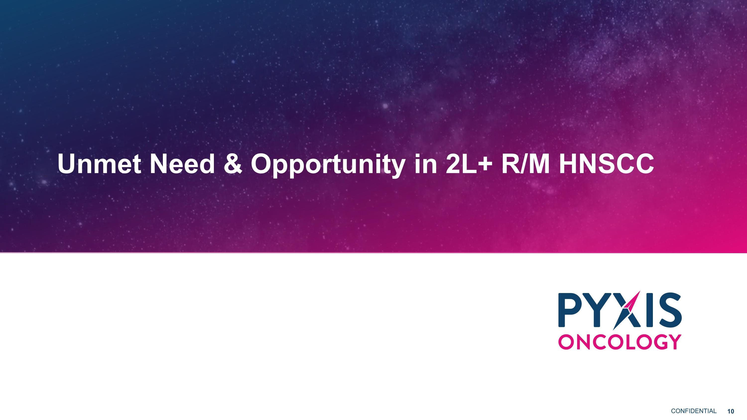
Unmet Need & Opportunity in 2L+ R/M HNSCC

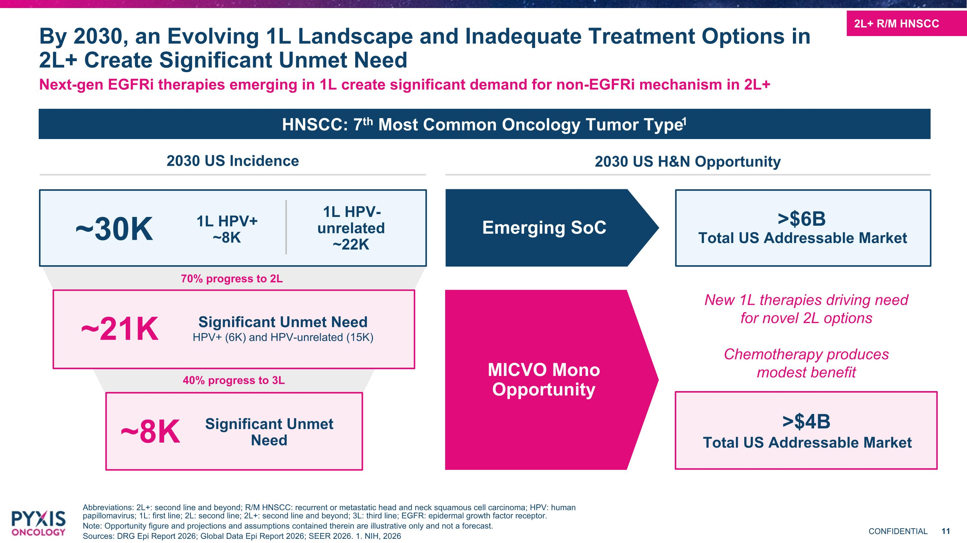
Next-gen EGFRi therapies emerging in 1L create significant demand for non-EGFRi mechanism in 2L+ Abbreviations: 2L+: second line and beyond; R/M HNSCC: recurrent or metastatic head and neck squamous cell carcinoma; HPV: human papillomavirus; 1L: first line; 2L: second line; 2L+: second line and beyond; 3L: third line; EGFR: epidermal growth factor receptor. Note: Opportunity figure and projections and assumptions contained therein are illustrative only and not a forecast. Sources: DRG Epi Report 2026; Global Data Epi Report 2026; SEER 2026. 1. NIH, 2026 By 2030, an Evolving 1L Landscape and Inadequate Treatment Options in 2L+ Create Significant Unmet Need ~21K Significant Unmet Need HPV+ (6K) and HPV-unrelated (15K) ~8K Significant Unmet Need MICVO Mono Opportunity Emerging SoC >$6B Total US Addressable Market >$4B Total US Addressable Market New 1L therapies driving need for novel 2L options Chemotherapy produces modest benefit 70% progress to 2L 40% progress to 3L 2L+ R/M HNSCC 2030 US Incidence 2030 US H&N Opportunity ~30K 1L HPV+ ~8K 1L HPV-unrelated ~22K HNSCC: 7th Most Common Oncology Tumor Type1

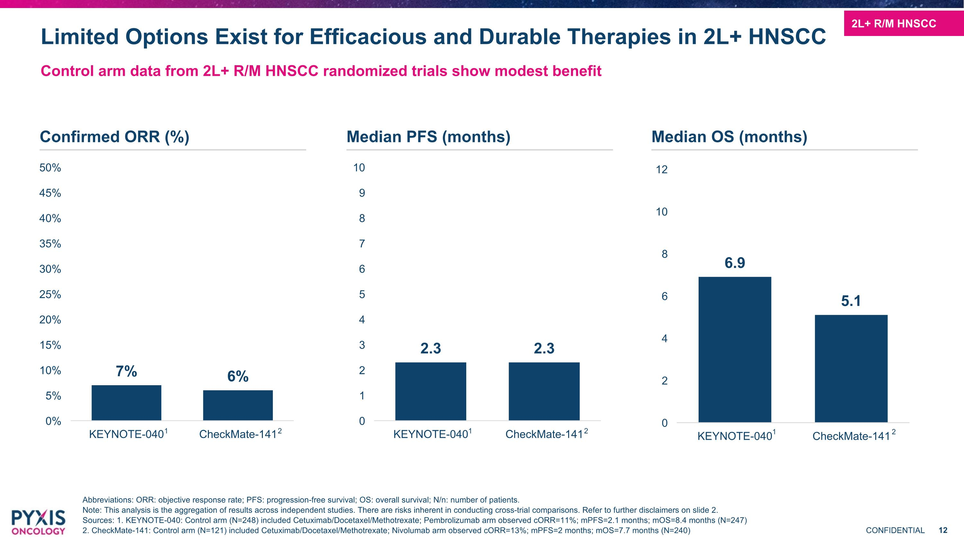
Control arm data from 2L+ R/M HNSCC randomized trials show modest benefit Abbreviations: ORR: objective response rate; PFS: progression-free survival; OS: overall survival; N/n: number of patients. Note: This analysis is the aggregation of results across independent studies. There are risks inherent in conducting cross-trial comparisons. Refer to further disclaimers on slide 2. Sources: 1. KEYNOTE-040: Control arm (N=248) included Cetuximab/Docetaxel/Methotrexate; Pembrolizumab arm observed cORR=11%; mPFS=2.1 months; mOS=8.4 months (N=247) 2. CheckMate-141: Control arm (N=121) included Cetuximab/Docetaxel/Methotrexate; Nivolumab arm observed cORR=13%; mPFS=2 months; mOS=7.7 months (N=240) Limited Options Exist for Efficacious and Durable Therapies in 2L+ HNSCC 2L+ R/M HNSCC Confirmed ORR (%) Median PFS (months) Median OS (months) 1 1 1 2 2 2

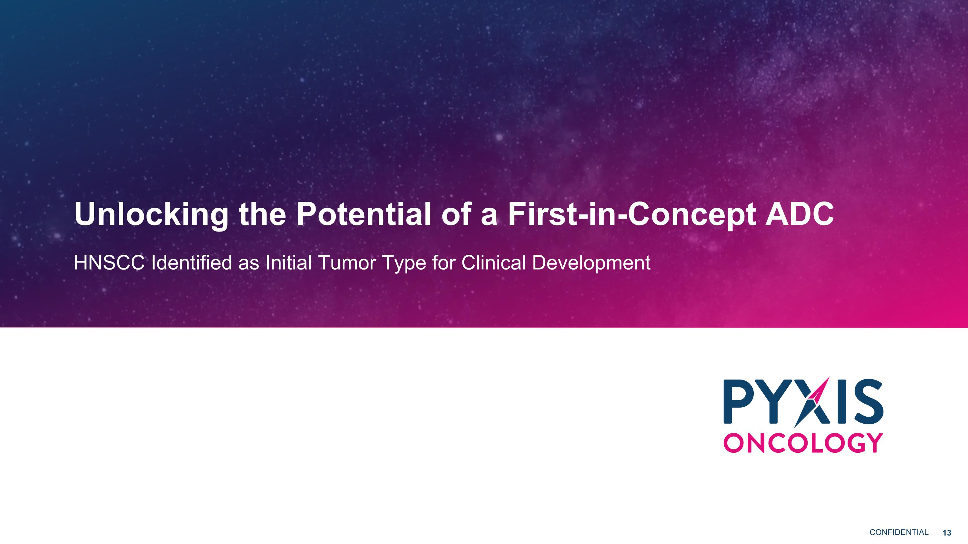
Unlocking the Potential of a First-in-Concept ADC HNSCC Identified as Initial Tumor Type for Clinical Development

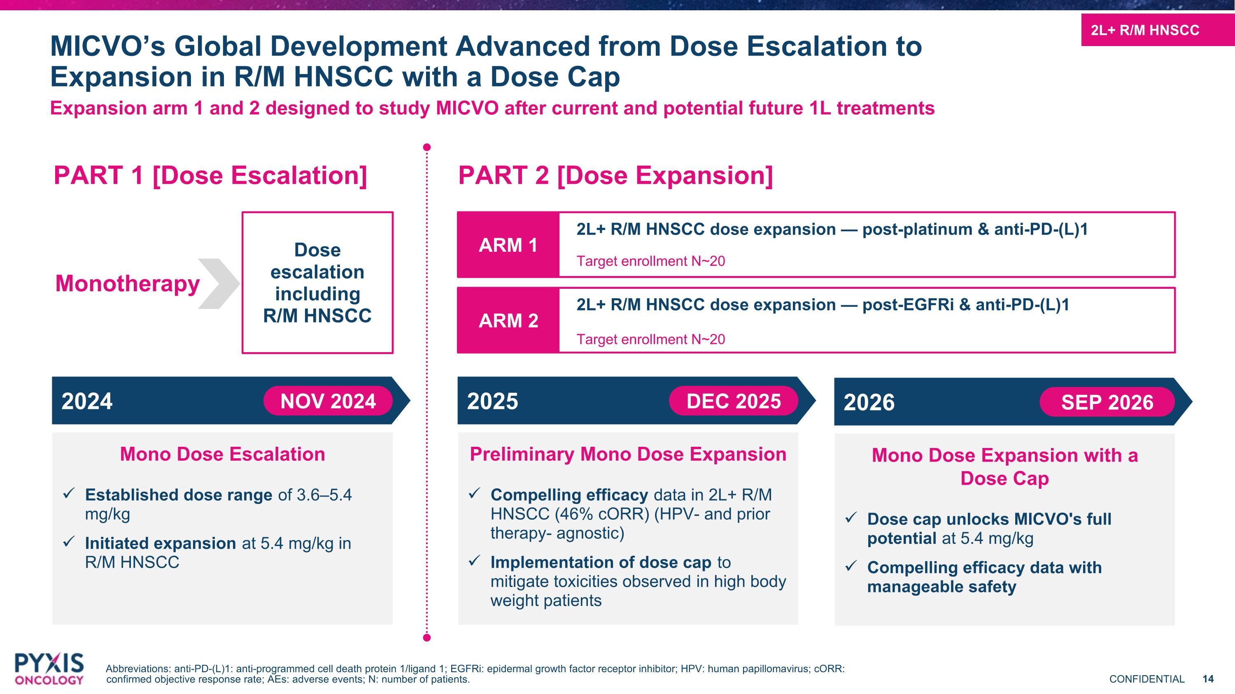
Expansion arm 1 and 2 designed to study MICVO after current and potential future 1L treatments Abbreviations: anti-PD-(L)1: anti-programmed cell death protein 1/ligand 1; EGFRi: epidermal growth factor receptor inhibitor; HPV: human papillomavirus; cORR: confirmed objective response rate; AEs: adverse events; N: number of patients. MICVO’s Global Development Advanced from Dose Escalation to Expansion in R/M HNSCC with a Dose Cap PART 1 [Dose Escalation] PART 2 [Dose Expansion] Monotherapy Dose escalation including R/M HNSCC ARM 1 2L+ R/M HNSCC dose expansion — post-platinum & anti-PD-(L)1 Target enrollment N~20 ARM 2 2L+ R/M HNSCC dose expansion — post-EGFRi & anti-PD-(L)1 Target enrollment N~20 2024 NOV 2024 Mono Dose Escalation Established dose range of 3.6–5.4 mg/kg Initiated expansion at 5.4 mg/kg in R/M HNSCC 2025 DEC 2025 Preliminary Mono Dose Expansion Compelling efficacy data in 2L+ R/M HNSCC (46% cORR) (HPV- and prior therapy- agnostic) Implementation of dose cap to mitigate toxicities observed in high body weight patients 2026 SEP 2026 Mono Dose Expansion with a ?Dose Cap Dose cap unlocks MICVO's full potential at 5.4 mg/kg Compelling efficacy data with manageable safety 2L+ R/M HNSCC

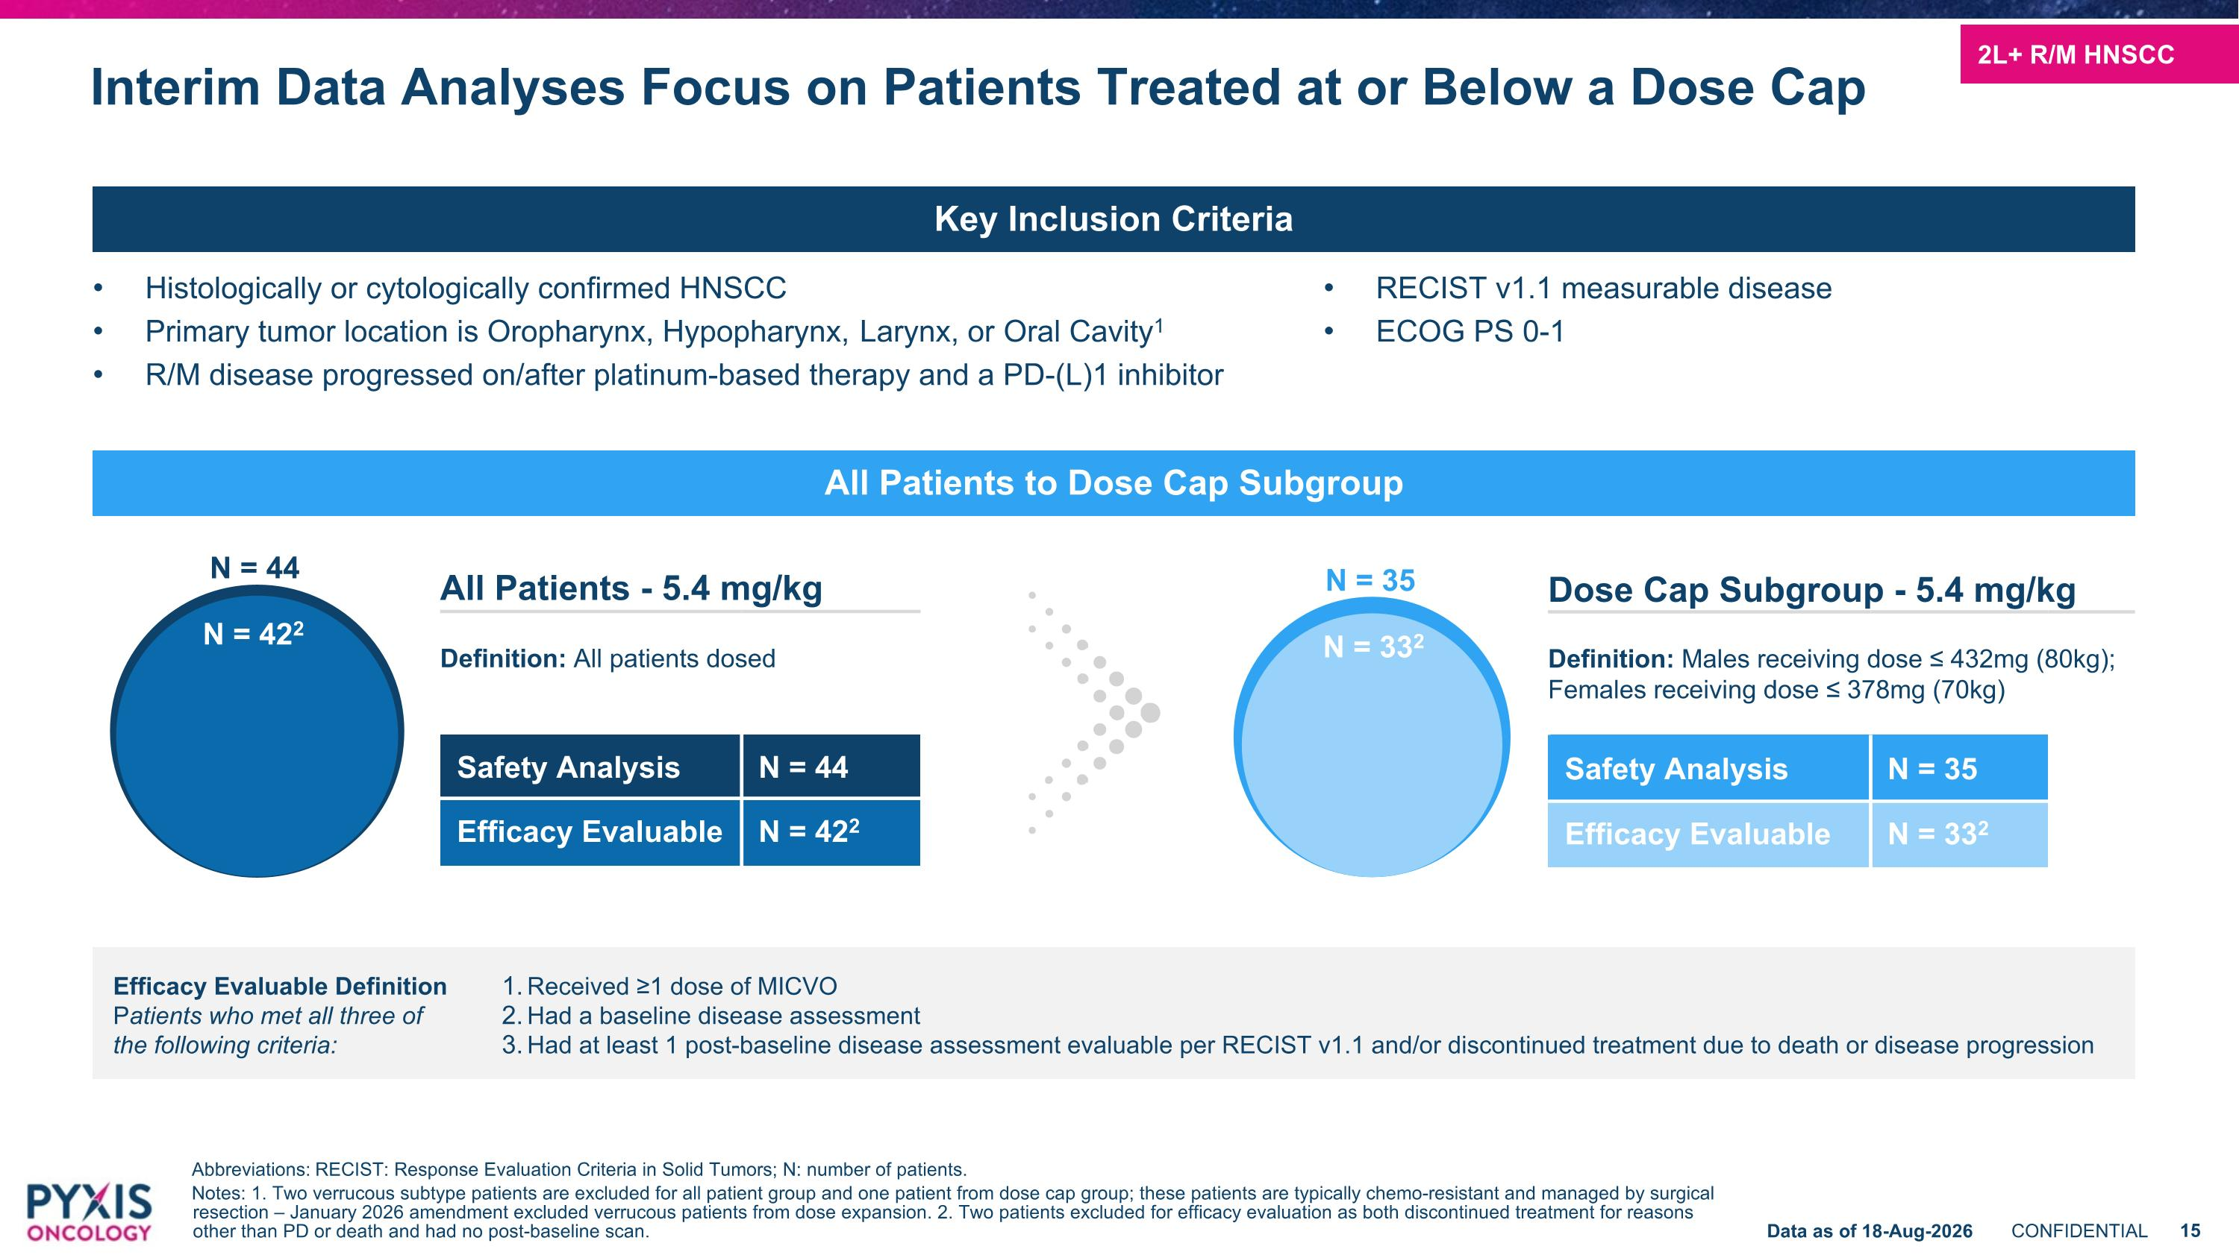
Interim Data Analyses Focus on Patients Treated at or Below a Dose Cap Abbreviations: RECIST: Response Evaluation Criteria in Solid Tumors; N: number of patients. Notes: 1. Two verrucous subtype patients are excluded for all patient group and one patient from dose cap group; these patients are typically chemo-resistant and managed by surgical resection – January 2026 amendment excluded verrucous patients from dose expansion. 2. Two patients excluded for efficacy evaluation as both discontinued treatment for reasons other than PD or death and had no post-baseline scan. Key Inclusion Criteria Histologically or cytologically confirmed HNSCC Primary tumor location is Oropharynx, Hypopharynx, Larynx, or Oral Cavity1 R/M disease progressed on/after platinum-based therapy and a PD-(L)1 inhibitor RECIST v1.1 measurable disease ECOG PS 0-1 Dose Cap Subgroup - 5.4 mg/kg Definition: Males receiving dose ≤ 432mg (80kg); Females receiving dose ≤ 378mg (70kg) Safety Analysis N = 35 Efficacy Evaluable N = 332 N = 44 N = 422 N = 332 N = 35 Received ≥1 dose of MICVO Had a baseline disease assessment Had at least 1 post-baseline disease assessment evaluable per RECIST v1.1 and/or discontinued treatment due to death or disease progression Efficacy Evaluable Definition?Patients who met all three of ?the following criteria: All Patients - 5.4 mg/kg Definition: All patients dosed Safety Analysis N = 44 Efficacy Evaluable N = 422 All Patients to Dose Cap Subgroup 2L+ R/M HNSCC Data as of 18-Aug-2026

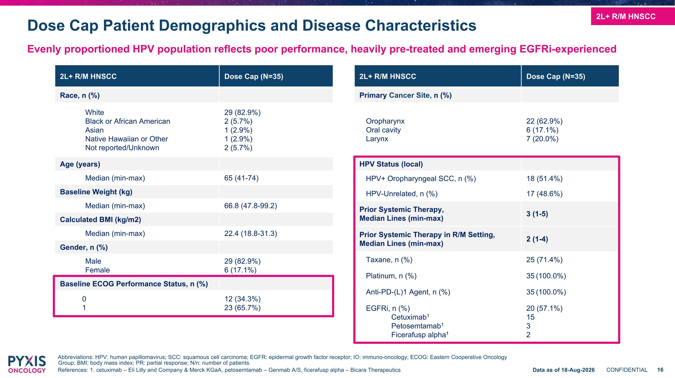
2L+ R/M HNSCC Dose Cap (N=35) Primary Cancer Site, n (%) Oropharynx Oral cavity Larynx 22 (62.9%) 6 (17.1%) 7 (20.0%) HPV Status (local) HPV+ Oropharyngeal SCC, n (%) 18 (51.4%) HPV-Unrelated, n (%) 17 (48.6%) Prior Systemic Therapy, Median Lines (min-max) 3 (1-5) Prior Systemic Therapy in R/M Setting, Median Lines (min-max) 2 (1-4) Taxane, n (%) 25 (71.4%) Platinum, n (%) 35 (100.0%) Anti-PD-(L)1 Agent, n (%) 35 (100.0%) EGFRi, n (%) Cetuximab1 Petosemtamab1 Ficerafusp alpha1 20 (57.1%) 15 3 2 2L+ R/M HNSCC Dose Cap (N=35) Race, n (%) White Black or African American Asian Native Hawaiian or Other Not reported/Unknown 29 (82.9%) 2 (5.7%) 1 (2.9%) 1 (2.9%) 2 (5.7%) Age (years) Median (min-max) 65 (41-74) Baseline Weight (kg) Median (min-max) 66.8 (47.8-99.2) Calculated BMI (kg/m2) Median (min-max) 22.4 (18.8-31.3) Gender, n (%) Male Female 29 (82.9%) 6 (17.1%) Baseline ECOG Performance Status, n (%) 0 1 12 (34.3%) 23 (65.7%) Dose Cap Patient Demographics and Disease Characteristics Evenly proportioned HPV population reflects poor performance, heavily pre-treated and emerging EGFRi-experienced Abbreviations: HPV: human papillomavirus; SCC: squamous cell carcinoma; EGFR: epidermal growth factor receptor; IO: immuno-oncology; ECOG: Eastern Cooperative Oncology Group; BMI: body mass index; PR: partial response; N/n: number of patients. References: 1. cetuximab – Eli Lilly and Company & Merck KGaA, petosemtamab – Genmab A/S, ficerafusp alpha – Bicara Therapeutics 2L+ R/M HNSCC Data as of 18-Aug-2026

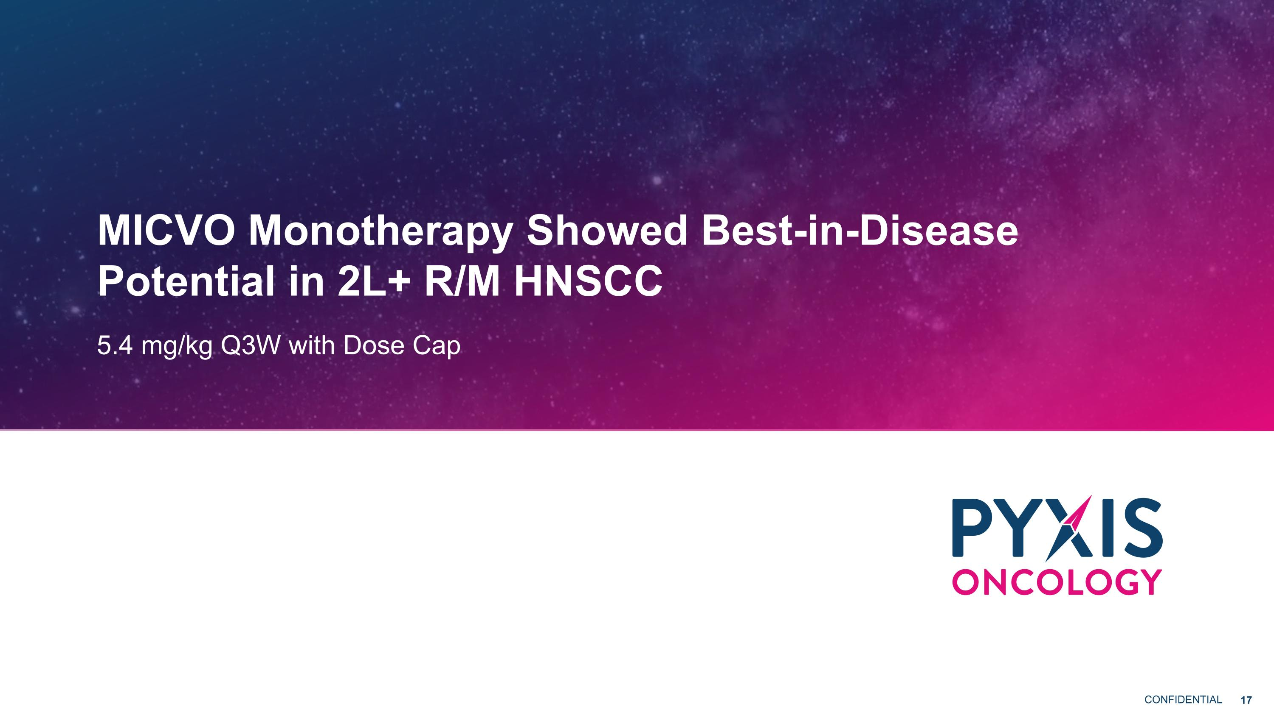
MICVO Monotherapy Showed Best-in-Disease Potential in 2L+ R/M HNSCC 5.4 mg/kg Q3W with Dose Cap

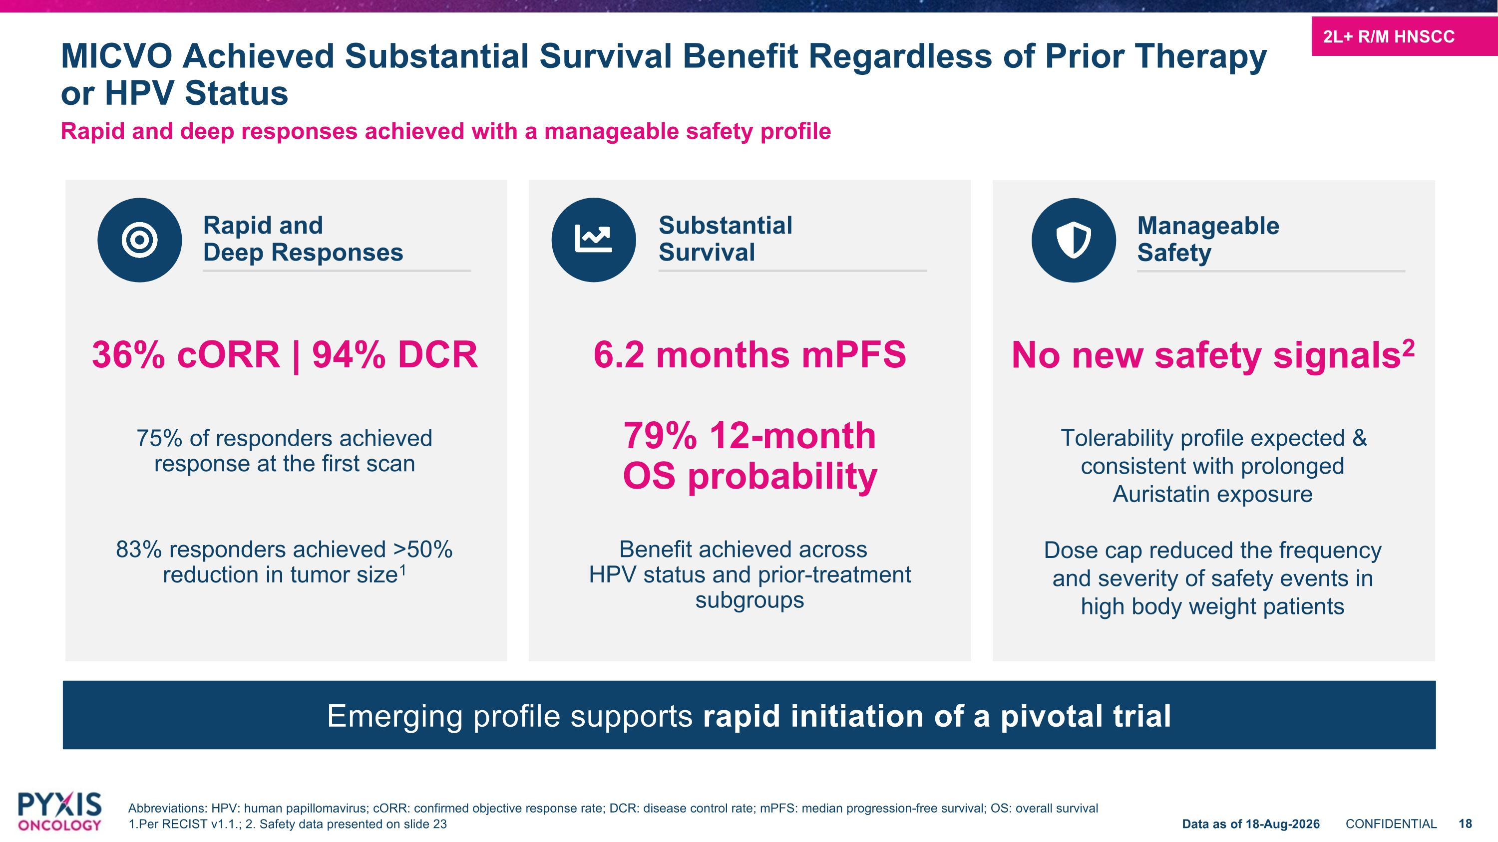
Rapid and deep responses achieved with a manageable safety profile MICVO Achieved Substantial Survival Benefit Regardless of Prior Therapy or HPV Status No new safety signals2 Tolerability profile expected & consistent with prolonged Auristatin exposure Dose cap reduced the frequency and severity of safety events in high body weight patients Emerging profile supports rapid initiation of a pivotal trial Manageable Safety 2L+ R/M HNSCC Data as of 18-Aug-2026 Abbreviations: HPV: human papillomavirus; cORR: confirmed objective response rate; DCR: disease control rate; mPFS: median progression-free survival; OS: overall survival 1.Per RECIST v1.1.; 2. Safety data presented on slide 23 6.2 months mPFS 79% 12-month OS probability Benefit achieved across HPV status and prior-treatment subgroups Substantial ?Survival 36% cORR | 94% DCR 75% of responders achieved response at the first scan 83% responders achieved >50% reduction in tumor size1 Rapid and ?Deep Responses

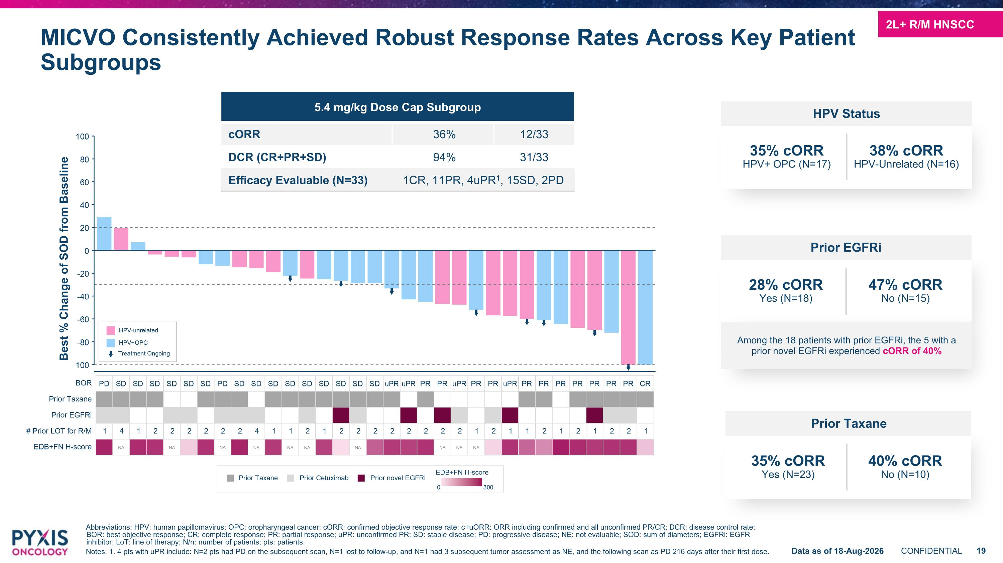
Abbreviations: HPV: human papillomavirus; OPC: oropharyngeal cancer; cORR: confirmed objective response rate; c+uORR: ORR including confirmed and all unconfirmed PR/CR; DCR: disease control rate; BOR: best objective response; CR: complete response; PR: partial response; uPR: unconfirmed PR; SD: stable disease; PD: progressive disease; NE: not evaluable; SOD: sum of diameters; EGFRi: EGFR inhibitor; LoT: line of therapy; N/n: number of patients; pts: patients. Notes: 1. 4 pts with uPR include: N=2 pts had PD on the subsequent scan, N=1 lost to follow-up, and N=1 had 3 subsequent tumor assessment as NE, and the following scan as PD 216 days after their first dose. MICVO Consistently Achieved Robust Response Rates Across Key Patient Subgroups Best % Change of SOD from Baseline 5.4 mg/kg Dose Cap Subgroup cORR 36% 12/33 DCR (CR+PR+SD) 94% 31/33 Efficacy Evaluable (N=33) 1CR, 11PR, 4uPR1, 15SD, 2PD 2L+ R/M HNSCC Data as of 18-Aug-2026 35% cORR HPV+ OPC (N=17) 38% cORR HPV-Unrelated (N=16) HPV Status Prior Taxane 35% cORR Yes (N=23) 40% cORR No (N=10) Prior EGFRi 28% cORR Yes (N=18) 47% cORR No (N=15) Among the 18 patients with prior EGFRi, the 5 with a prior novel EGFRi experienced cORR of 40%

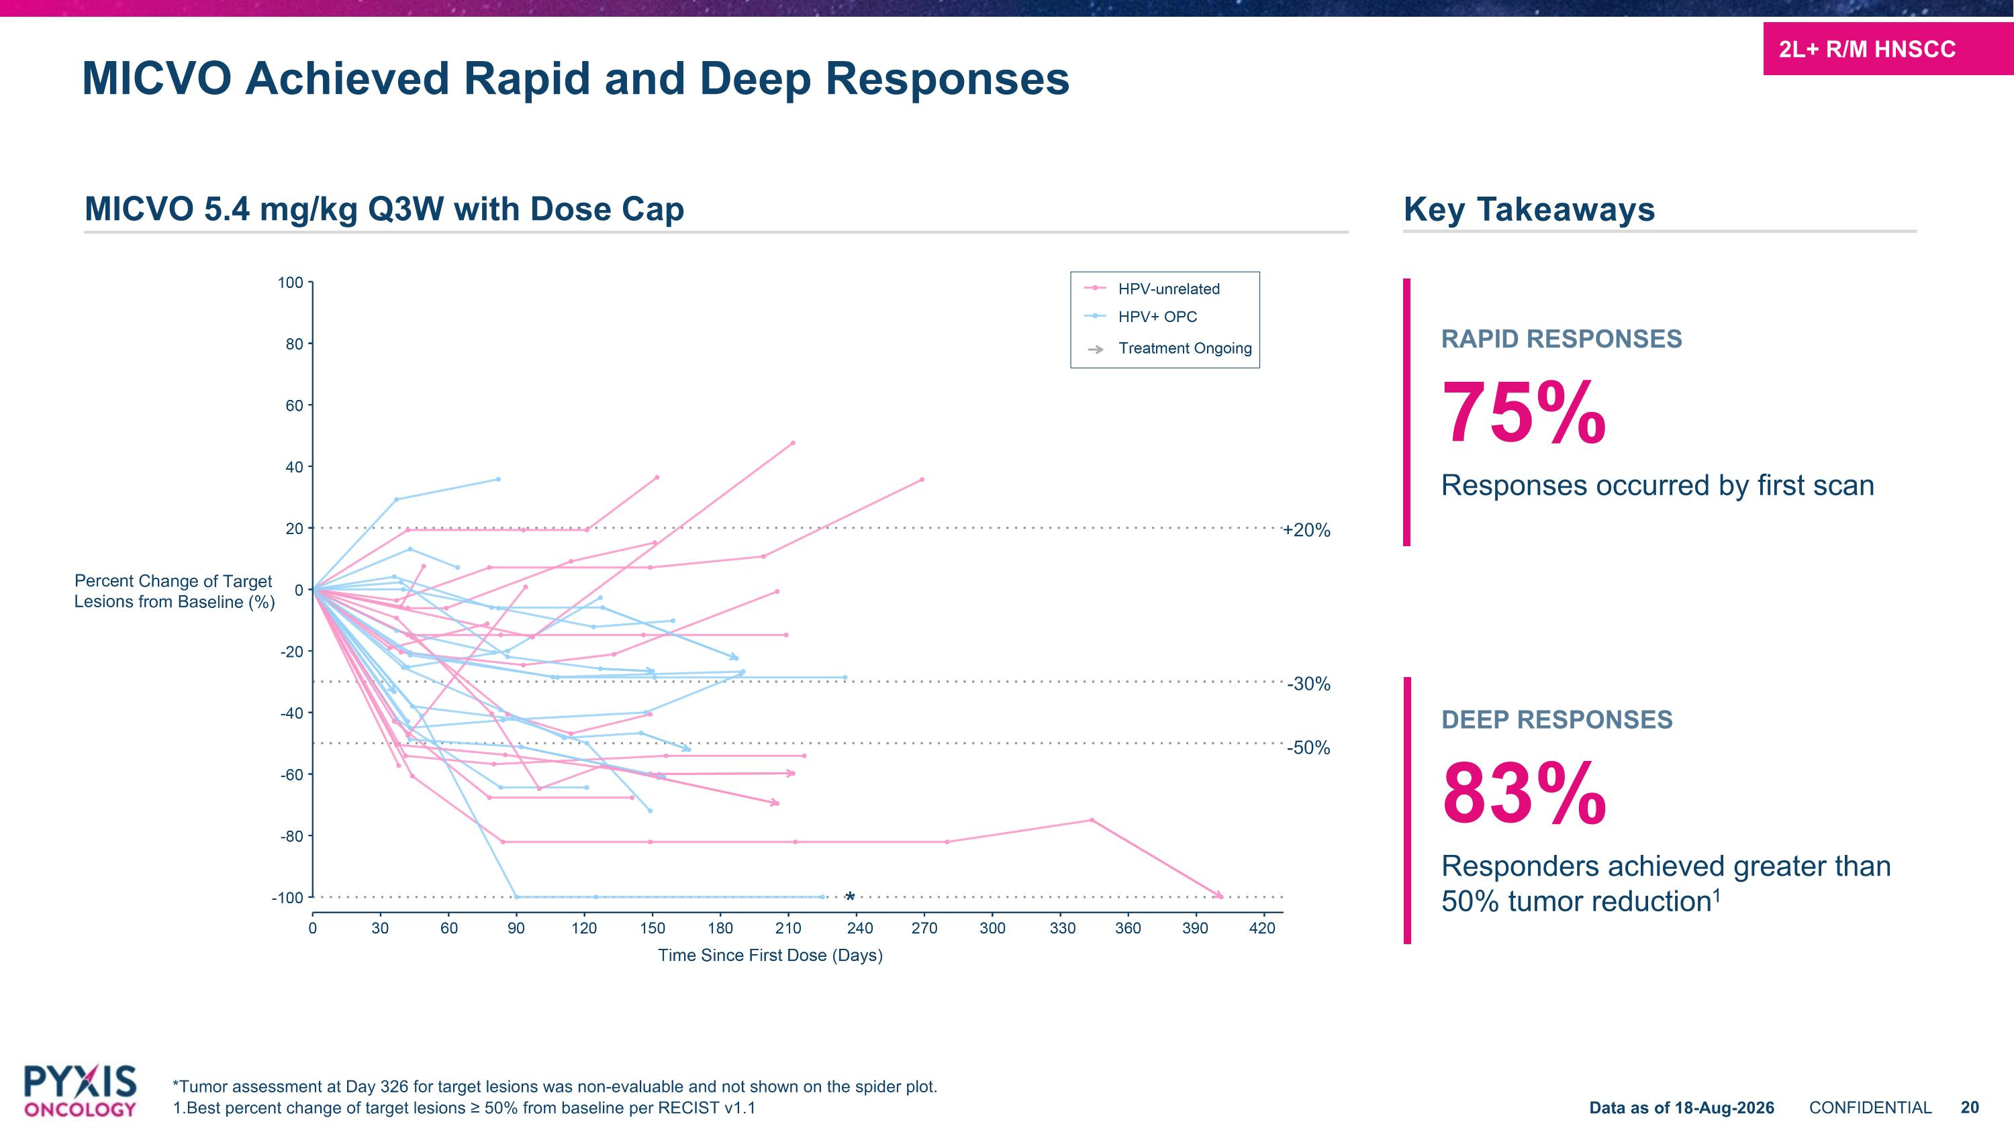
* -50% -30% +20% MICVO Achieved Rapid and Deep Responses *Tumor assessment at Day 326 for target lesions was non-evaluable and not shown on the spider plot. 1.Best percent change of target lesions ≥ 50% from baseline per RECIST v1.1 Key Takeaways MICVO 5.4 mg/kg Q3W with Dose Cap RAPID RESPONSES 75% Responses occurred by first scan DEEP RESPONSES 83% Responders achieved greater than 50% tumor reduction1 2L+ R/M HNSCC Data as of 18-Aug-2026

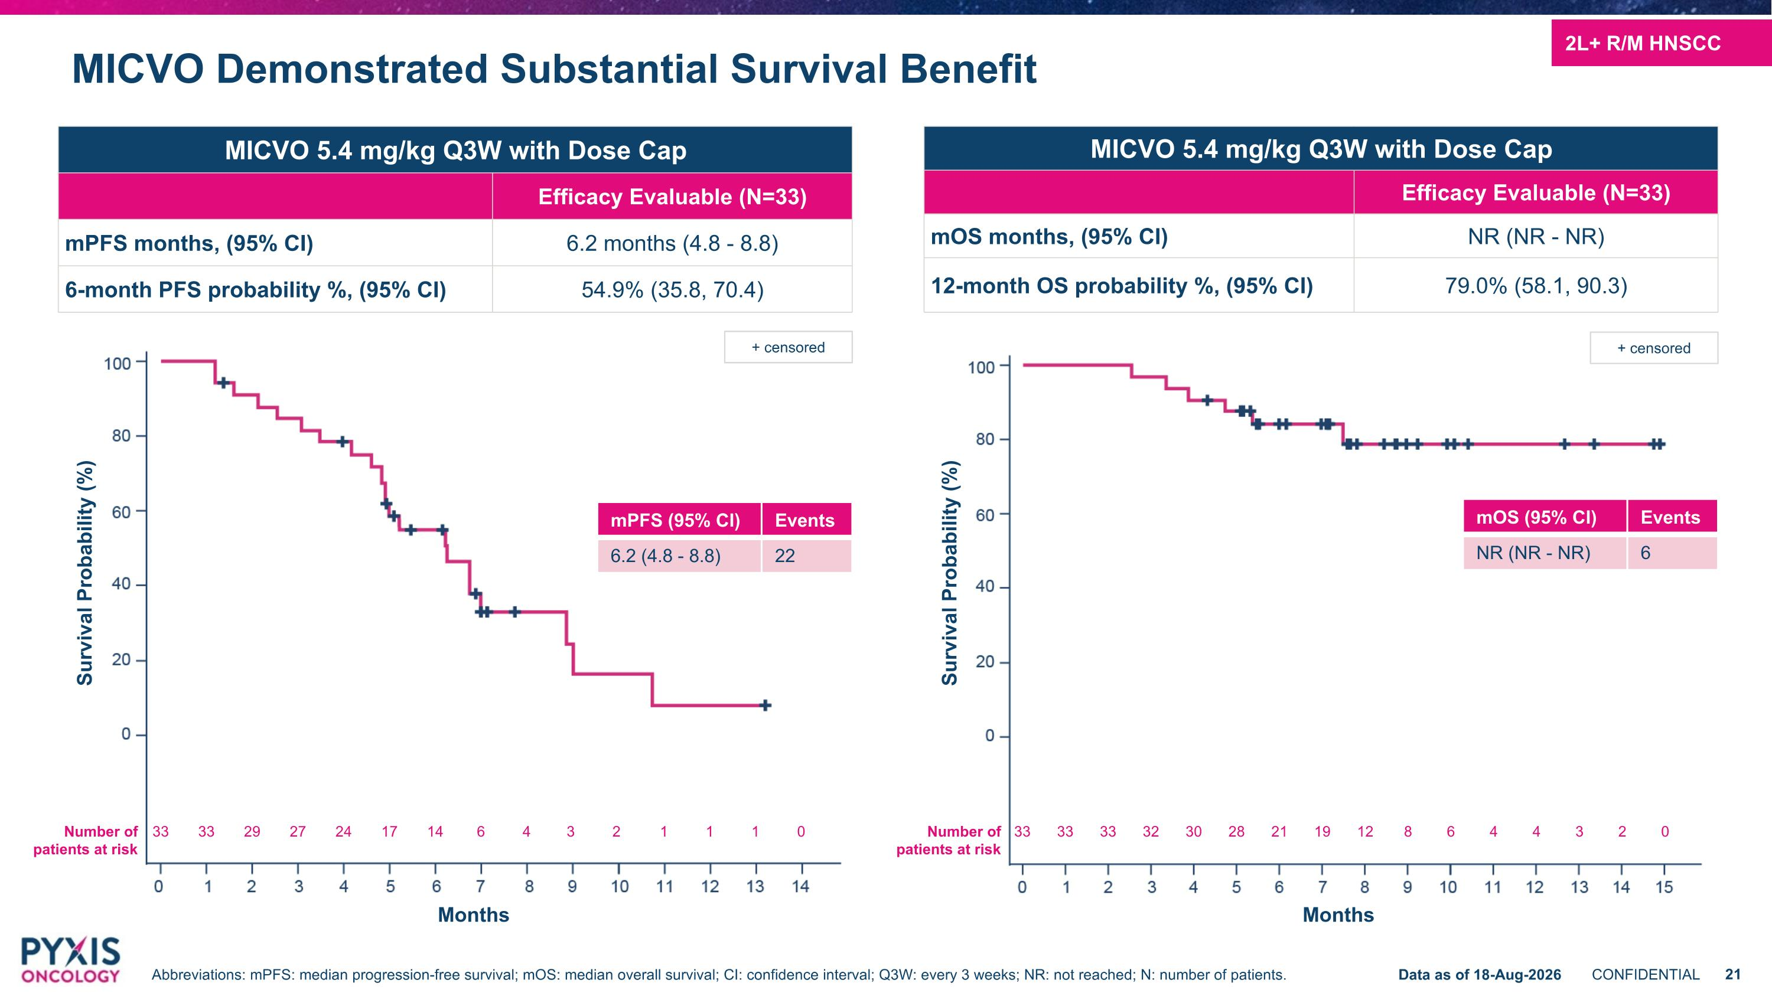
+ censored MICVO Demonstrated Substantial Survival Benefit MICVO 5.4 mg/kg Q3W with Dose Cap Efficacy Evaluable (N=33) mPFS months, (95% CI) 6.2 months (4.8 - 8.8) 6-month PFS probability %, (95% CI) 54.9% (35.8, 70.4) MICVO 5.4 mg/kg Q3W with Dose Cap Efficacy Evaluable (N=33) mOS months, (95% CI) NR (NR - NR) 12-month OS probability %, (95% CI) 79.0% (58.1, 90.3) Number of patients at risk 33 33 33 32 30 28 21 19 12 8 6 4 4 3 2 0 Survival Probability (%) Months Number of patients at risk 33 33 29 27 24 17 14 6 4 3 2 1 1 1 0 Survival Probability (%) Months + censored 2L+ R/M HNSCC Abbreviations: mPFS: median progression-free survival; mOS: median overall survival; CI: confidence interval; Q3W: every 3 weeks; NR: not reached; N: number of patients. Data as of 18-Aug-2026 mPFS (95% CI) Events 6.2 (4.8 - 8.8) 22 mOS (95% CI) Events NR (NR - NR) 6

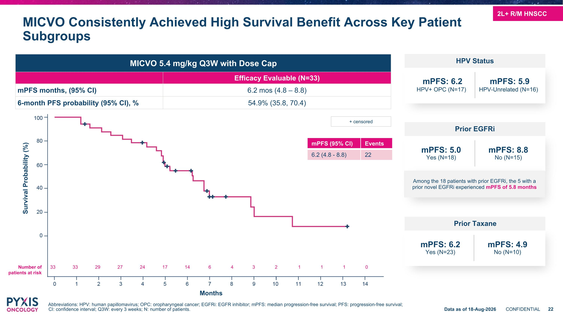
MICVO Consistently Achieved High Survival Benefit Across Key Patient Subgroups MICVO 5.4 mg/kg Q3W with Dose Cap Efficacy Evaluable (N=33) mPFS months, (95% CI) 6.2 mos (4.8 – 8.8) 6-month PFS probability (95% CI), % 54.9% (35.8, 70.4) + censored Survival Probability (%) Months Number of patients at risk 33 33 29 27 24 17 14 6 4 3 2 1 1 1 0 Abbreviations: HPV: human papillomavirus; OPC: oropharyngeal cancer; EGFRi: EGFR inhibitor; mPFS: median progression-free survival; PFS: progression-free survival; CI: confidence interval; Q3W: every 3 weeks; N: number of patients. Data as of 18-Aug-2026 mPFS (95% CI) Events 6.2 (4.8 - 8.8) 22 2L+ R/M HNSCC mPFS: 6.2 HPV+ OPC (N=17) mPFS: 5.9 HPV-Unrelated (N=16) HPV Status Prior Taxane mPFS: 6.2 Yes (N=23) mPFS: 4.9 No (N=10) Prior EGFRi mPFS: 5.0 Yes (N=18) mPFS: 8.8 No (N=15) Among the 18 patients with prior EGFRi, the 5 with a prior novel EGFRi experienced mPFS of 5.8 months

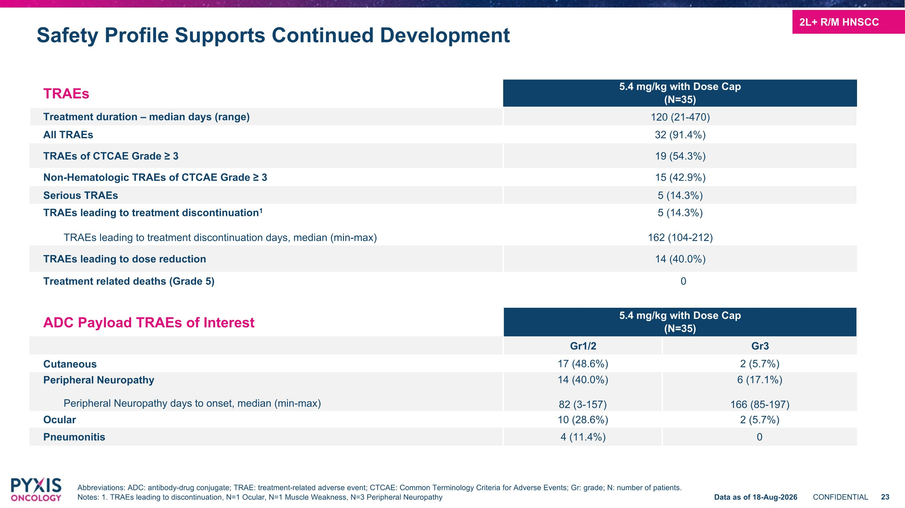
TRAEs 5.4 mg/kg with Dose Cap (N=35) Treatment duration – median days (range) 120 (21-470) All TRAEs 32 (91.4%) TRAEs of CTCAE Grade ≥ 3 19 (54.3%) Non-Hematologic TRAEs of CTCAE Grade ≥ 3 15 (42.9%) Serious TRAEs 5 (14.3%) TRAEs leading to treatment discontinuation1 TRAEs leading to treatment discontinuation days, median (min-max) 5 (14.3%) 162 (104-212) TRAEs leading to dose reduction 14 (40.0%) Treatment related deaths (Grade 5) 0 ADC Payload TRAEs of Interest 5.4 mg/kg with Dose Cap (N=35) Gr1/2 Gr3 Cutaneous 17 (48.6%) 2 (5.7%) Peripheral Neuropathy Peripheral Neuropathy days to onset, median (min-max) 14 (40.0%) 82 (3-157) 6 (17.1%) 166 (85-197) Ocular 10 (28.6%) 2 (5.7%) Pneumonitis 4 (11.4%) 0 Safety Profile Supports Continued Development Abbreviations: ADC: antibody-drug conjugate; TRAE: treatment-related adverse event; CTCAE: Common Terminology Criteria for Adverse Events; Gr: grade; N: number of patients. Notes: 1. TRAEs leading to discontinuation, N=1 Ocular, N=1 Muscle Weakness, N=3 Peripheral Neuropathy 2L+ R/M HNSCC Data as of 18-Aug-2026

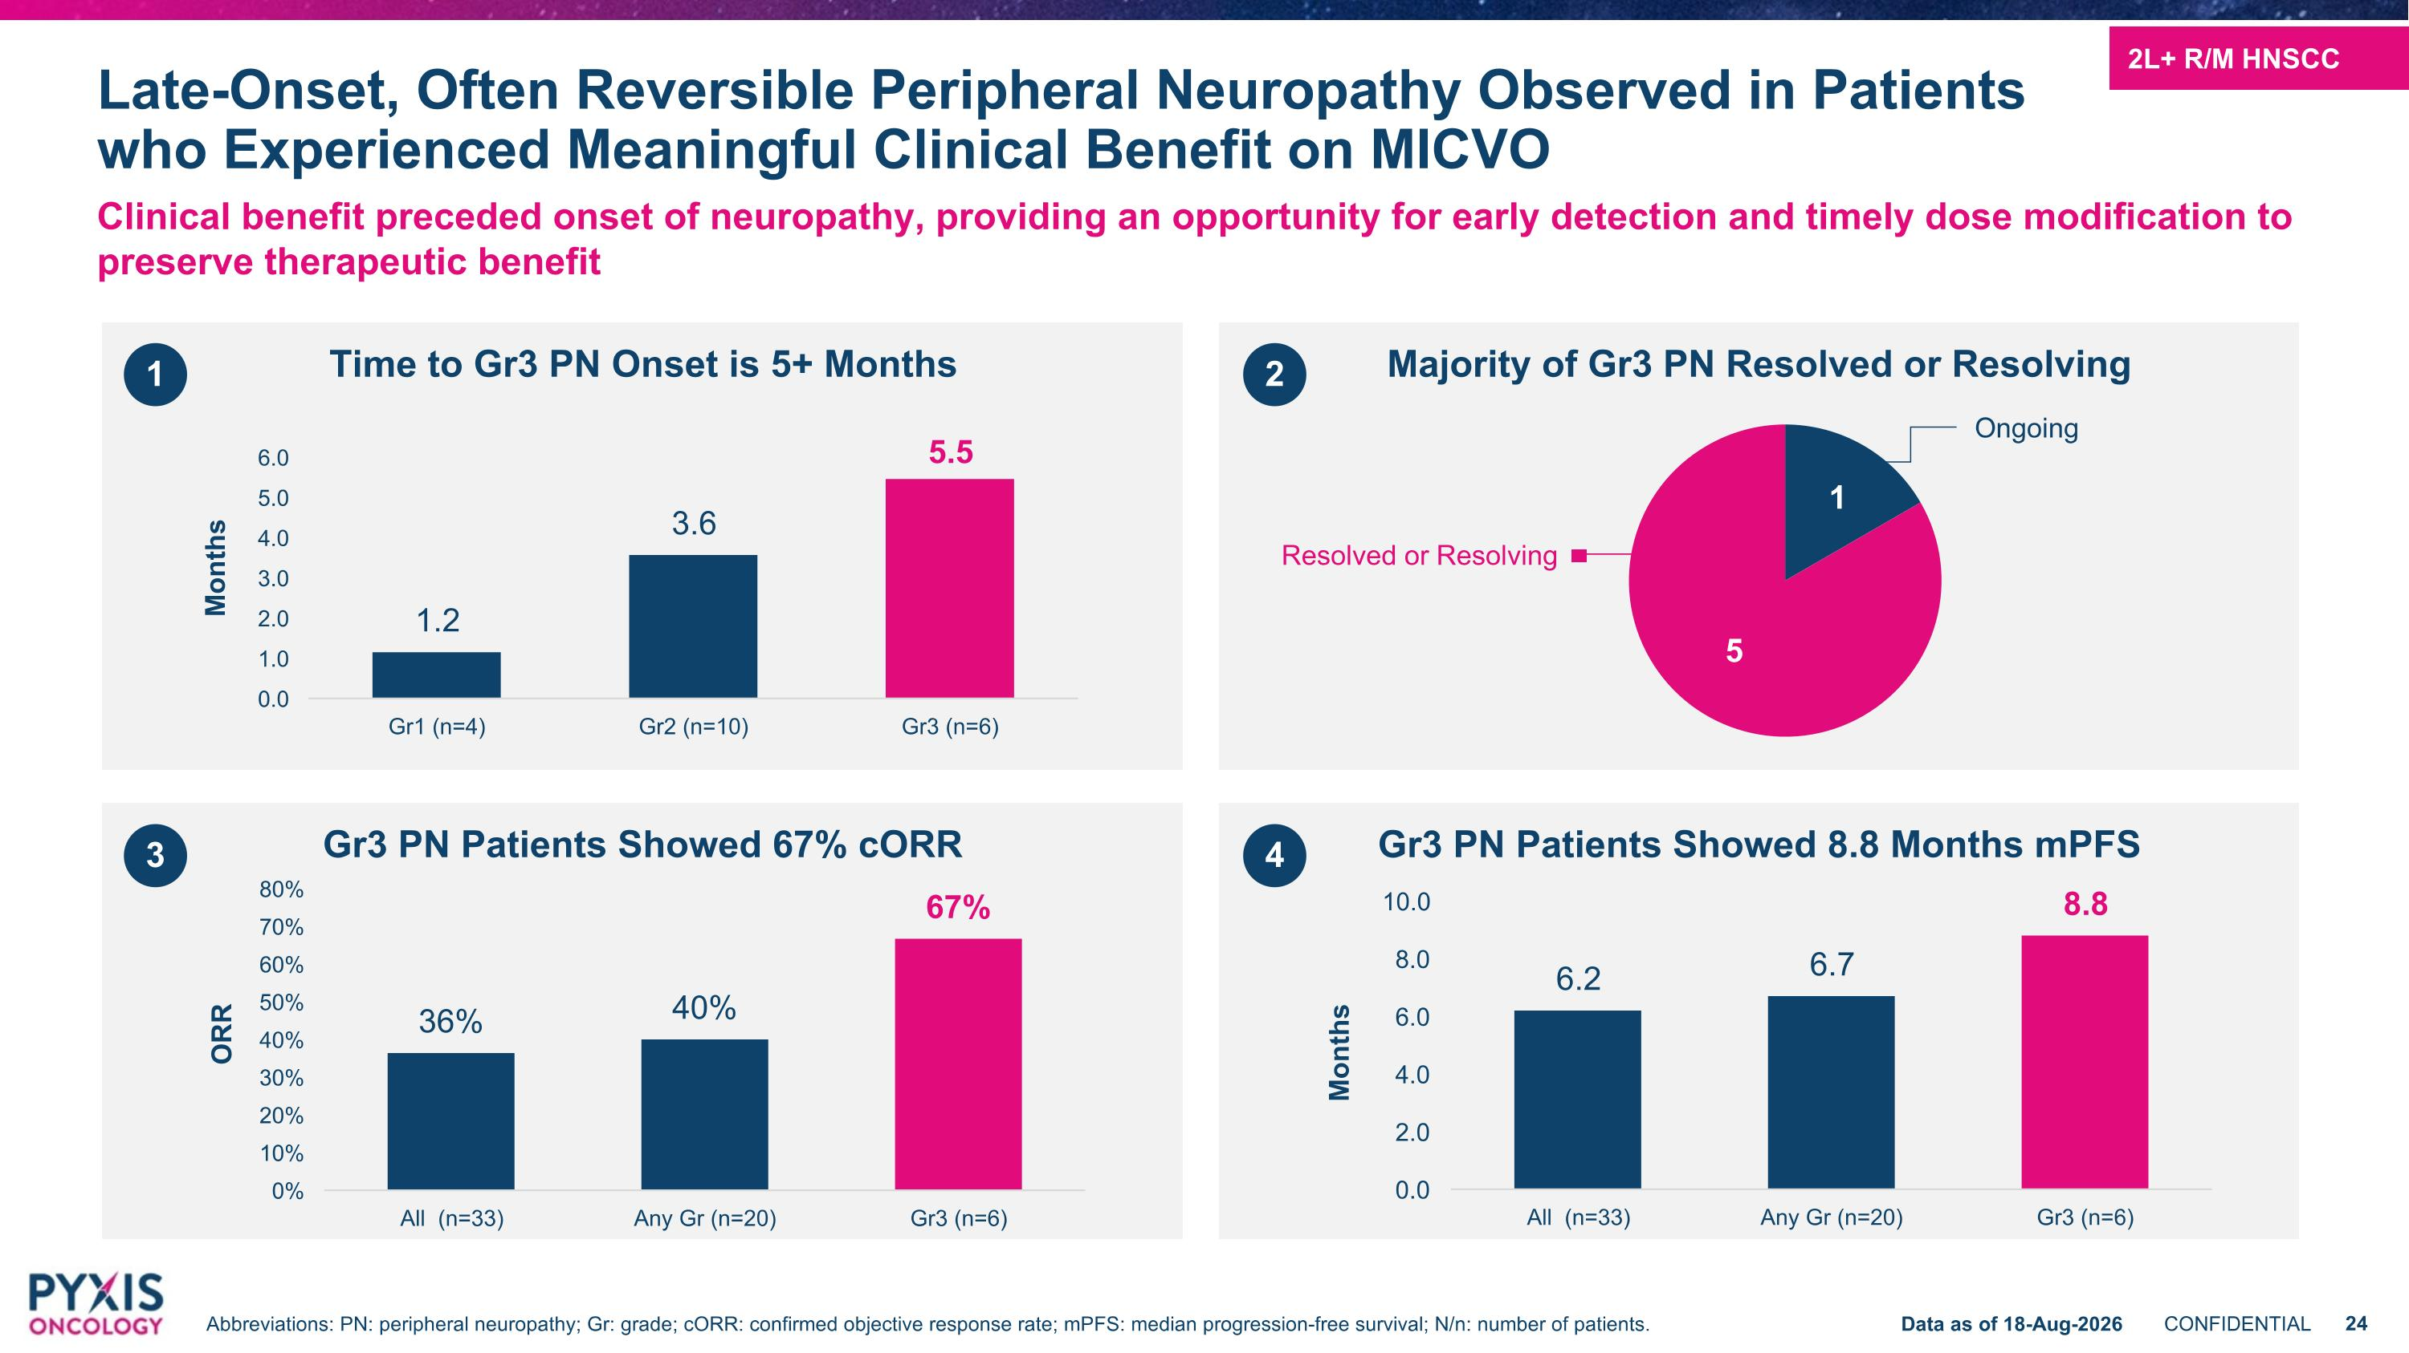
Time to Gr3 PN Onset is 5+ Months Gr3 PN Patients Showed 67% cORR Majority of Gr3 PN Resolved or Resolving Gr3 PN Patients Showed 8.8 Months mPFS Clinical benefit preceded onset of neuropathy, providing an opportunity for early detection and timely dose modification to preserve therapeutic benefit Late-Onset, Often Reversible Peripheral Neuropathy Observed in Patients who Experienced Meaningful Clinical Benefit on MICVO 1 Months ORR Ongoing Months 3 2 4 2L+ R/M HNSCC Data as of 18-Aug-2026 Abbreviations: PN: peripheral neuropathy; Gr: grade; cORR: confirmed objective response rate; mPFS: median progression-free survival; N/n: number of patients. Resolved or Resolving

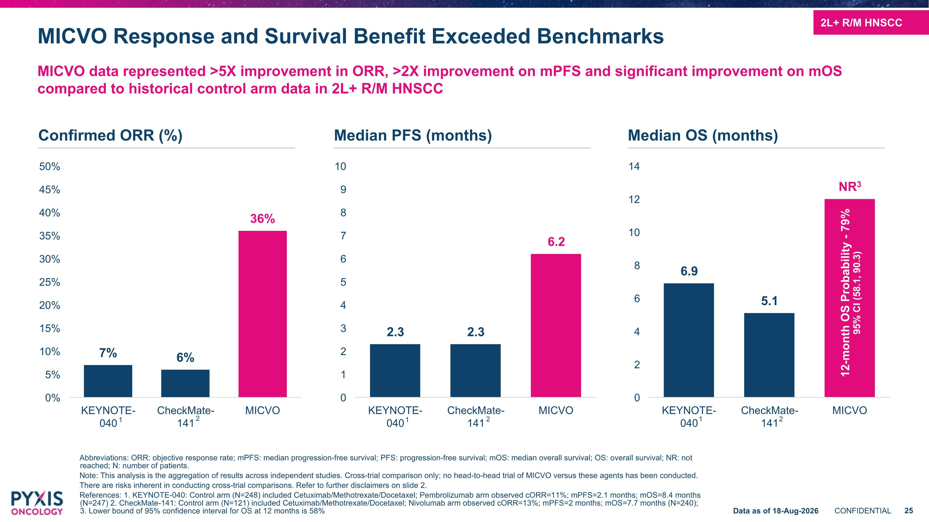
MICVO Response and Survival Benefit Exceeded Benchmarks MICVO data represented >5X improvement in ORR, >2X improvement on mPFS and significant improvement on mOS compared to historical control arm data in 2L+ R/M HNSCC Abbreviations: ORR: objective response rate; mPFS: median progression-free survival; PFS: progression-free survival; mOS: median overall survival; OS: overall survival; NR: not reached; N: number of patients. Note: This analysis is the aggregation of results across independent studies. Cross-trial comparison only; no head-to-head trial of MICVO versus these agents has been conducted. There are risks inherent in conducting cross-trial comparisons. Refer to further disclaimers on slide 2. References: 1. KEYNOTE-040: Control arm (N=248) included Cetuximab/Methotrexate/Docetaxel; Pembrolizumab arm observed cORR=11%; mPFS=2.1 months; mOS=8.4 months (N=247) 2. CheckMate-141: Control arm (N=121) included Cetuximab/Methotrexate/Docetaxel; Nivolumab arm observed cORR=13%; mPFS=2 months; mOS=7.7 months (N=240); ?3. Lower bound of 95% confidence interval for OS at 12 months is 58% Confirmed ORR (%) Median PFS (months) Median OS (months) 2L+ R/M HNSCC Data as of 18-Aug-2026 12-month OS Probability - 79% 95% CI (58.1, 90.3) 1 1 1 2 2 2


Next Steps in Clinical Development

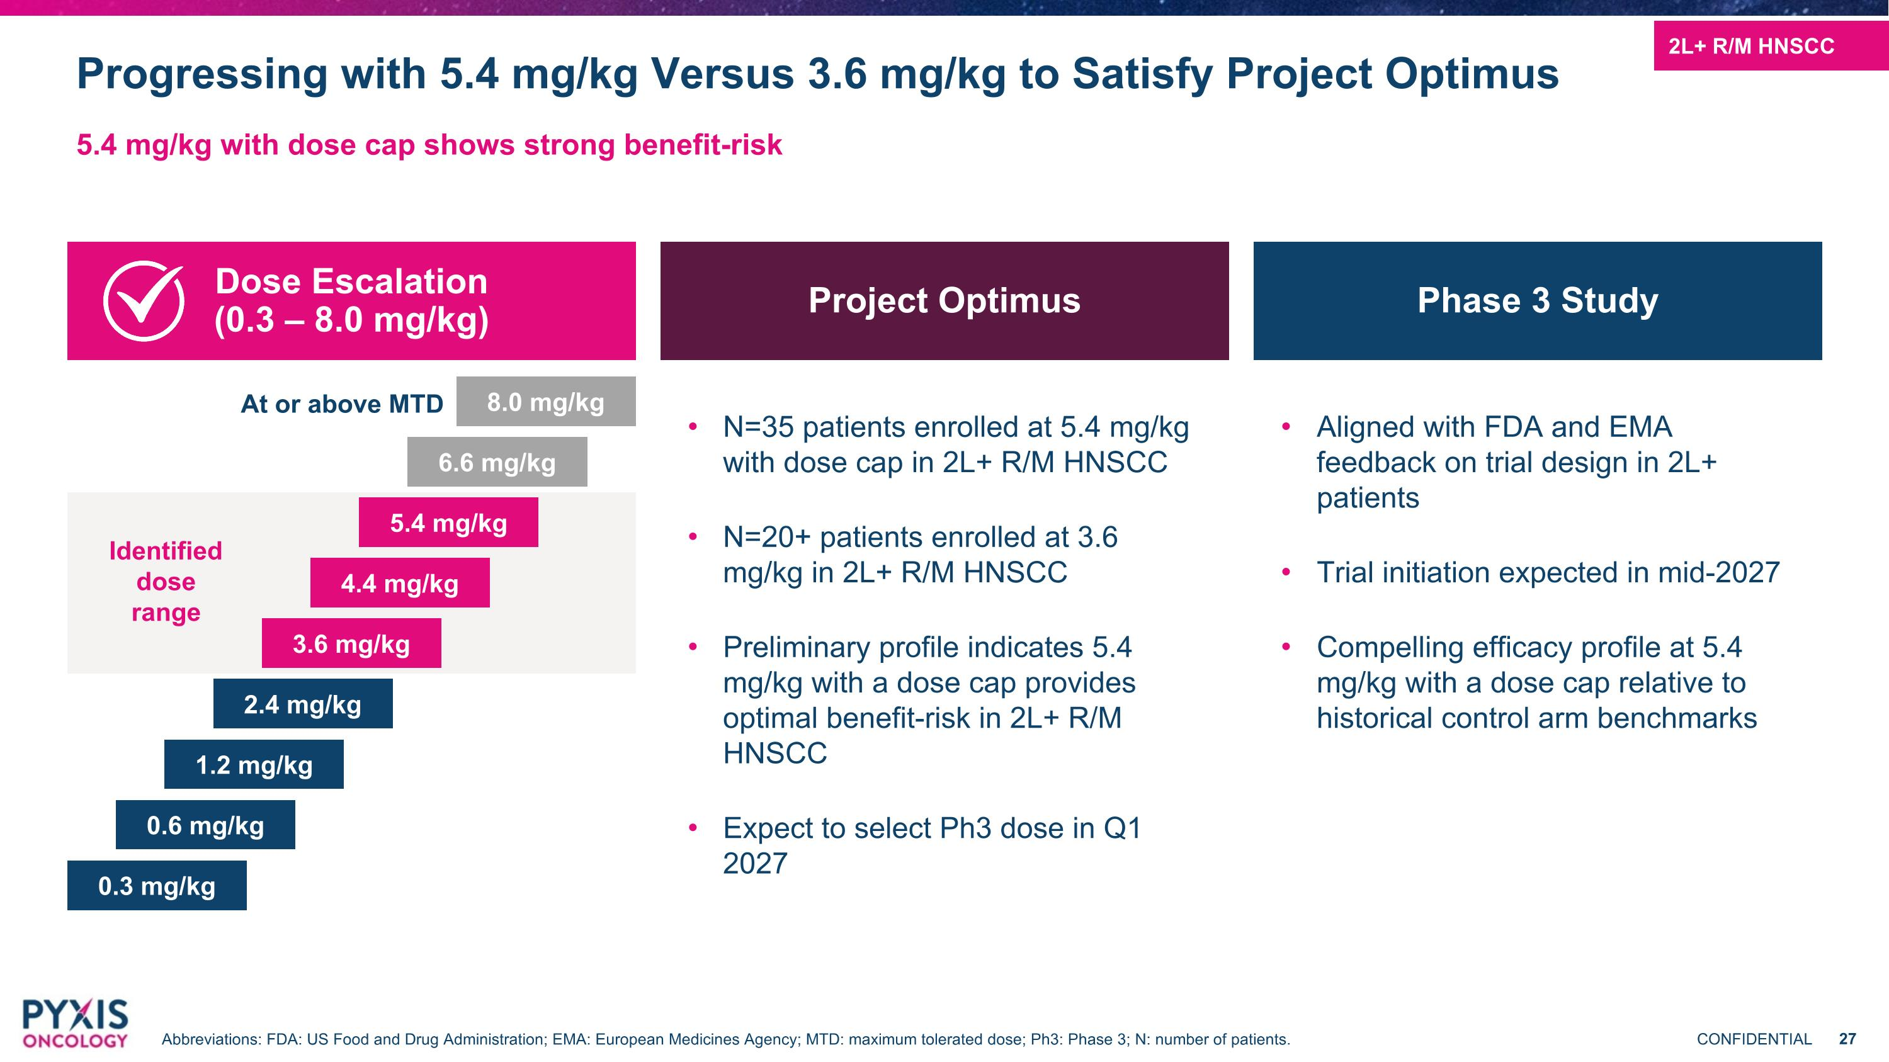
Progressing with 5.4 mg/kg Versus 3.6 mg/kg to Satisfy Project Optimus 5.4 mg/kg with dose cap shows strong benefit-risk N=35 patients enrolled at 5.4 mg/kg with dose cap in 2L+ R/M HNSCC N=20+ patients enrolled at 3.6 mg/kg in 2L+ R/M HNSCC Preliminary profile indicates 5.4 mg/kg with a dose cap provides optimal benefit-risk in 2L+ R/M HNSCC Expect to select Ph3 dose in Q1 2027 Dose Escalation?(0.3 – 8.0 mg/kg) Project Optimus Phase 3 Study Aligned with FDA and EMA feedback on trial design in 2L+ patients Trial initiation expected in mid-2027 Compelling efficacy profile at 5.4 mg/kg with a dose cap relative to historical control arm benchmarks 0.3 mg/kg 0.6 mg/kg 1.2 mg/kg 2.4 mg/kg 3.6 mg/kg 4.4 mg/kg 5.4 mg/kg 6.6 mg/kg 8.0 mg/kg Identified dose range At or above MTD 2L+ R/M HNSCC Abbreviations: FDA: US Food and Drug Administration; EMA: European Medicines Agency; MTD: maximum tolerated dose; Ph3: Phase 3; N: number of patients.

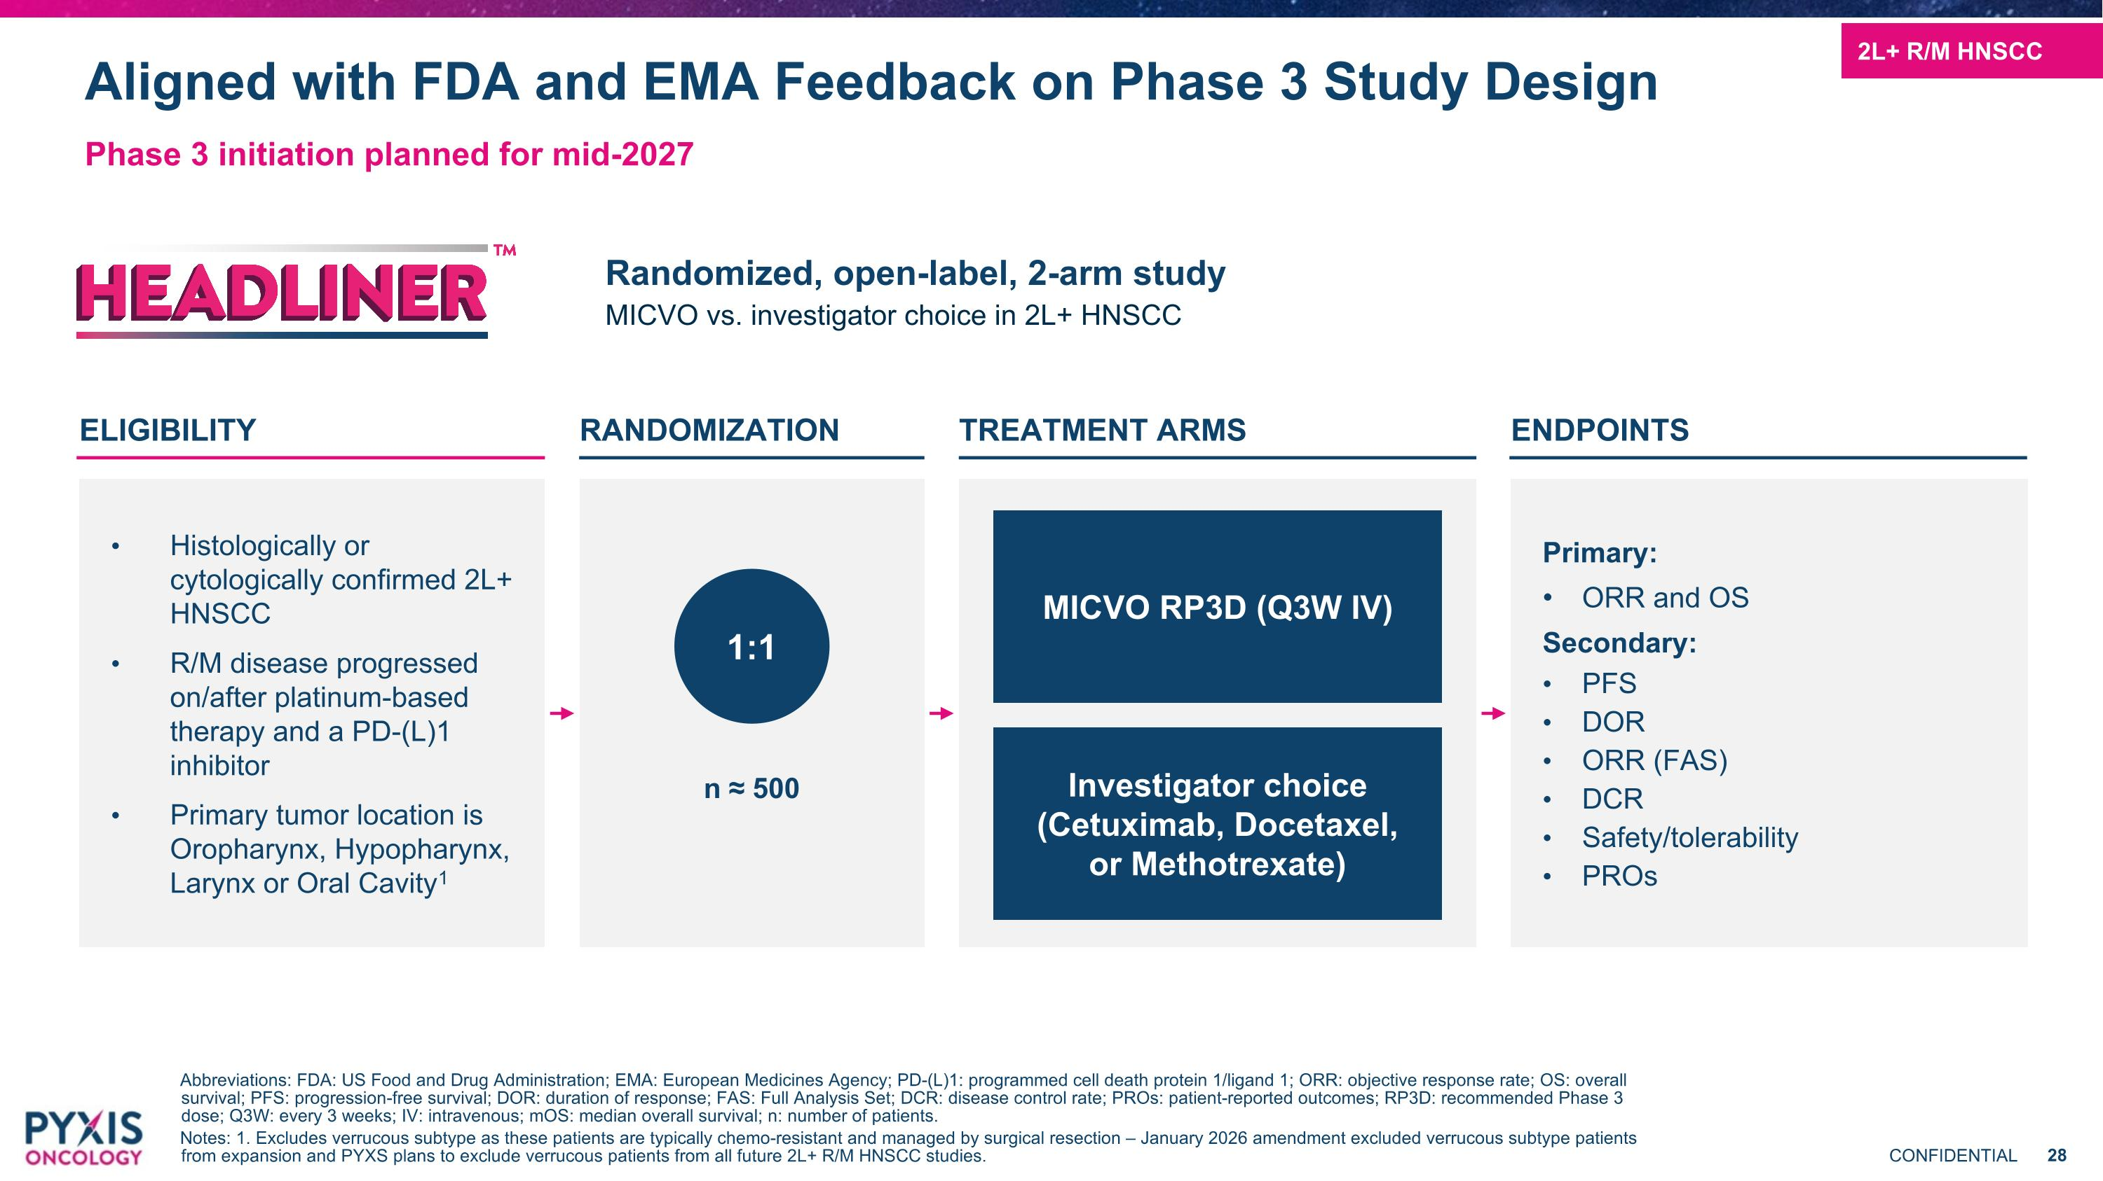
Aligned with FDA and EMA Feedback on Phase 3 Study Design Phase 3 initiation planned for mid-2027 Abbreviations: FDA: US Food and Drug Administration; EMA: European Medicines Agency; PD-(L)1: programmed cell death protein 1/ligand 1; ORR: objective response rate; OS: overall survival; PFS: progression-free survival; DOR: duration of response; FAS: Full Analysis Set; DCR: disease control rate; PROs: patient-reported outcomes; RP3D: recommended Phase 3 dose; Q3W: every 3 weeks; IV: intravenous; mOS: median overall survival; n: number of patients. Notes: 1. Excludes verrucous subtype as these patients are typically chemo-resistant and managed by surgical resection – January 2026 amendment excluded verrucous subtype patients from expansion and PYXS plans to exclude verrucous patients from all future 2L+ R/M HNSCC studies. Randomized, open-label, 2-arm study MICVO vs. investigator choice in 2L+ HNSCC ELIGIBILITY Histologically or cytologically confirmed 2L+ HNSCC R/M disease progressed on/after platinum-based therapy and a PD-(L)1 inhibitor Primary tumor location is Oropharynx, Hypopharynx, Larynx or Oral Cavity1 RANDOMIZATION TREATMENT ARMS ENDPOINTS Primary: ORR and OS Secondary: PFS DOR ORR (FAS) DCR Safety/tolerability PROs 1:1 n ≈ 500 MICVO RP3D (Q3W IV) Investigator choice (Cetuximab, Docetaxel, or Methotrexate) 2L+ R/M HNSCC

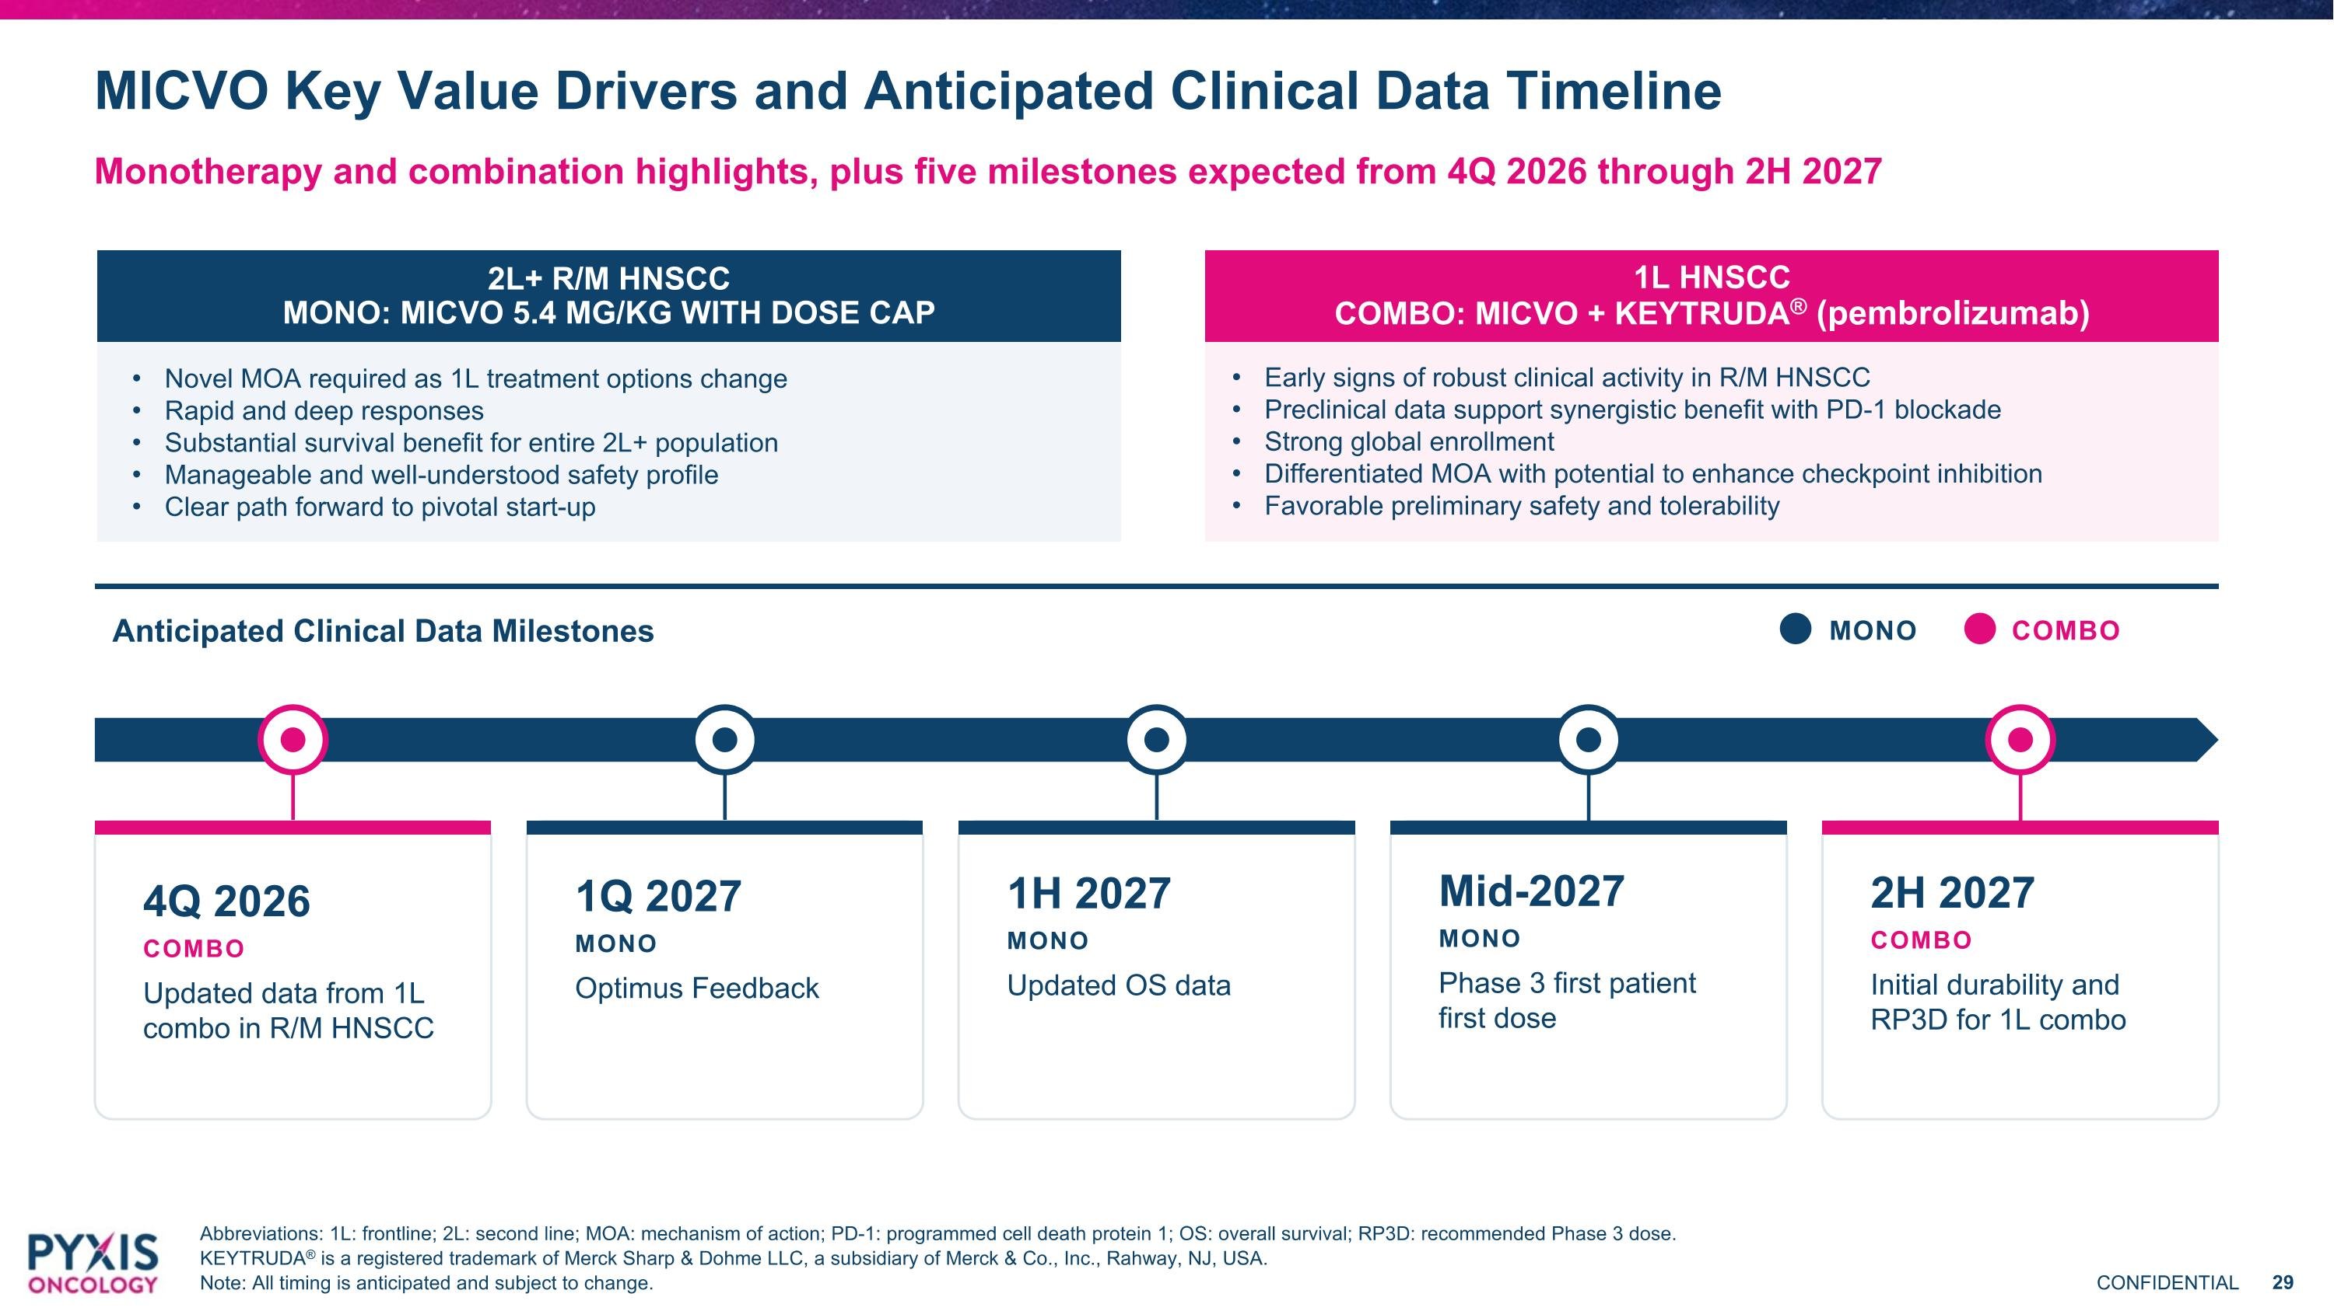
MICVO Key Value Drivers and Anticipated Clinical Data Timeline Monotherapy and combination highlights, plus five milestones expected from 4Q 2026 through 2H 2027 Abbreviations: 1L: frontline; 2L: second line; MOA: mechanism of action; PD-1: programmed cell death protein 1; OS: overall survival; RP3D: recommended Phase 3 dose. KEYTRUDA® is a registered trademark of Merck Sharp & Dohme LLC, a subsidiary of Merck & Co., Inc., Rahway, NJ, USA. Note: All timing is anticipated and subject to change. 2L+ R/M HNSCC MONO: MICVO 5.4 MG/KG WITH DOSE CAP Novel MOA required as 1L treatment options change Rapid and deep responses Substantial survival benefit for entire 2L+ population Manageable and well-understood safety profile Clear path forward to pivotal start-up 1L HNSCC COMBO: MICVO + KEYTRUDA® (pembrolizumab) Early signs of robust clinical activity in R/M HNSCC Preclinical data support synergistic benefit with PD-1 blockade Strong global enrollment Differentiated MOA with potential to enhance checkpoint inhibition Favorable preliminary safety and tolerability Anticipated Clinical Data Milestones MONO COMBO 4Q 2026 COMBO Updated data from 1L combo in R/M HNSCC 2H 2027 COMBO Initial durability and RP3D for 1L combo Mid-2027 MONO Phase 3 first patient first dose 1H 2027 MONO Updated OS data 1Q 2027 MONO Optimus Feedback

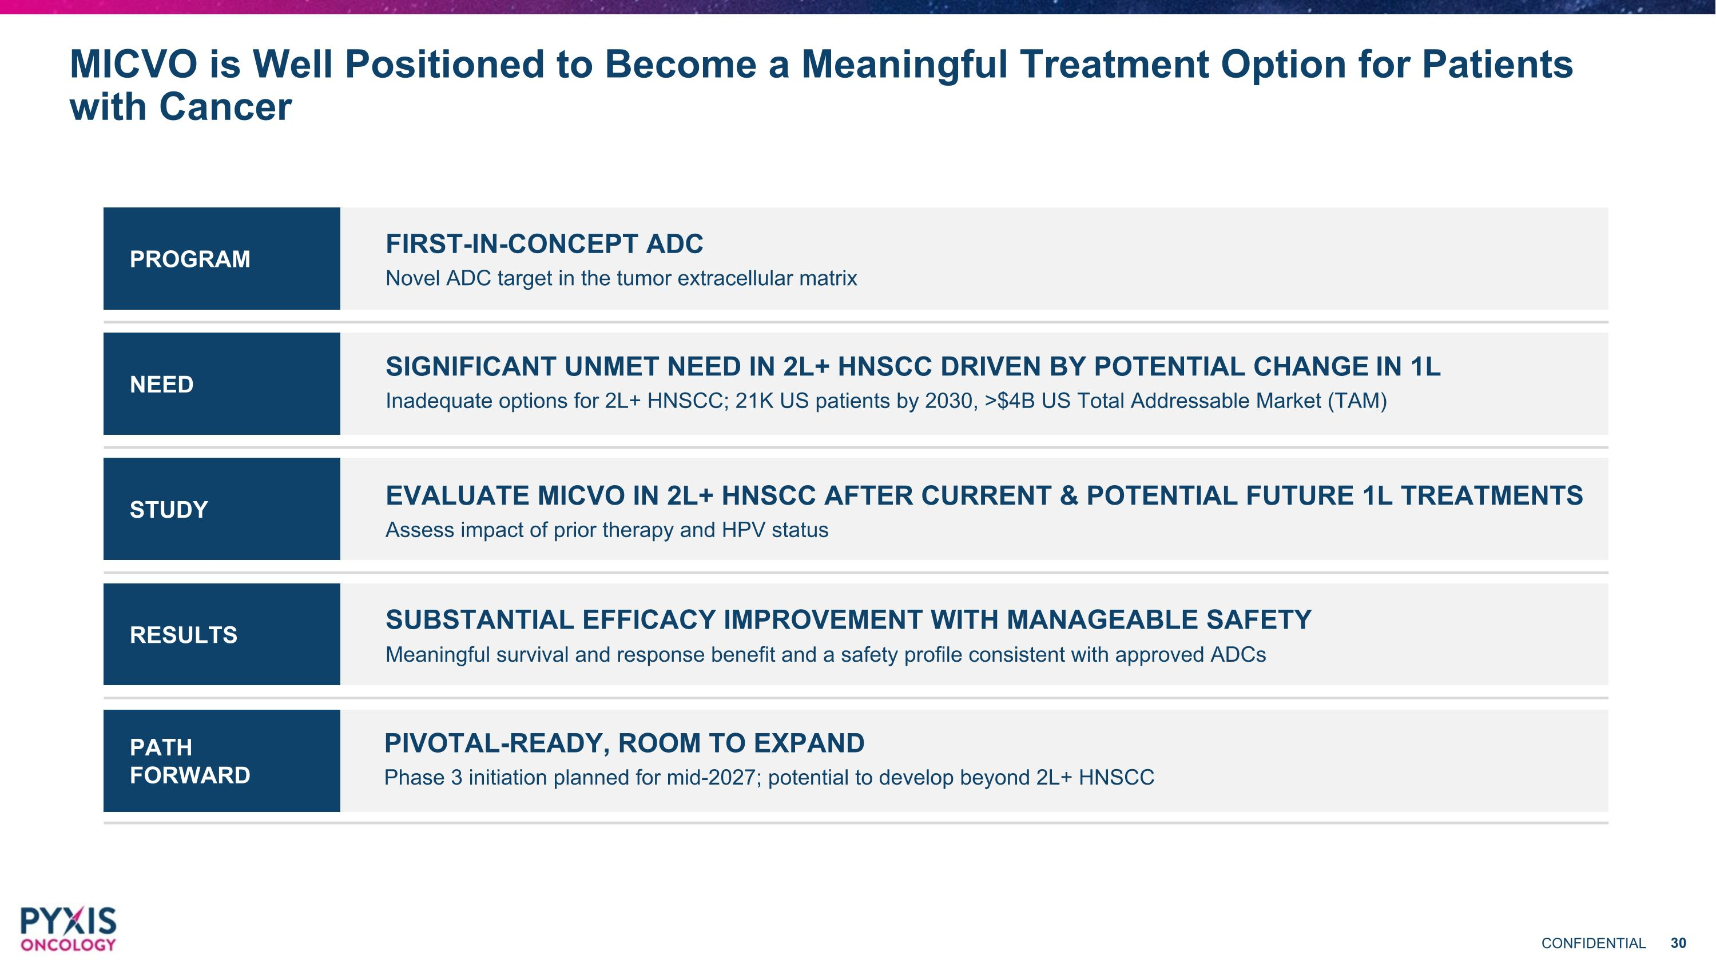
PATH FORWARD RESULTS STUDY NEED MICVO is Well Positioned to Become a Meaningful Treatment Option for Patients with Cancer PROGRAM FIRST-IN-CONCEPT ADC Novel ADC target in the tumor extracellular matrix SIGNIFICANT UNMET NEED IN 2L+ HNSCC DRIVEN BY POTENTIAL CHANGE IN 1L Inadequate options for 2L+ HNSCC; 21K US patients by 2030, >$4B US Total Addressable Market (TAM) EVALUATE MICVO IN 2L+ HNSCC AFTER CURRENT & POTENTIAL FUTURE 1L TREATMENTS Assess impact of prior therapy and HPV status SUBSTANTIAL EFFICACY IMPROVEMENT WITH MANAGEABLE SAFETY Meaningful survival and response benefit and a safety profile consistent with approved ADCs PIVOTAL-READY, ROOM TO EXPAND Phase 3 initiation planned for mid-2027; potential to develop beyond 2L+ HNSCC


Charting a Course to Therapeutics for Difficult-to-Treat Cancers September 9, 2026

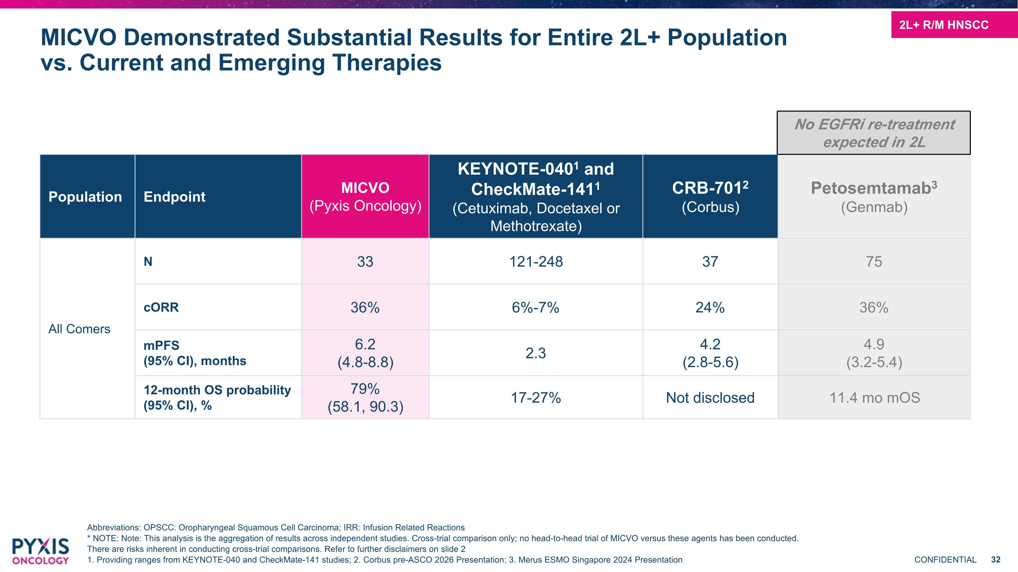
2L+ R/M HNSCC MICVO Demonstrated Substantial Results for Entire 2L+ Population vs. Current and Emerging Therapies Abbreviations: OPSCC: Oropharyngeal Squamous Cell Carcinoma; IRR: Infusion Related Reactions * NOTE: Note: This analysis is the aggregation of results across independent studies. Cross-trial comparison only; no head-to-head trial of MICVO versus these agents has been conducted. There are risks inherent in conducting cross-trial comparisons. Refer to further disclaimers on slide 2 1. Providing ranges from KEYNOTE-040 and CheckMate-141 studies; 2. Corbus pre-ASCO 2026 Presentation; 3. Merus ESMO Singapore 2024 Presentation Population Endpoint MICVO (Pyxis Oncology) KEYNOTE-0401 and CheckMate-1411 (Cetuximab, Docetaxel or Methotrexate) CRB-7012 (Corbus) Petosemtamab3 (Genmab) All Comers N 33 121-248 37 75 cORR 36% 6%-7% 24% 36% mPFS (95% CI), months 6.2 (4.8-8.8) 2.3 4.2 (2.8-5.6) 4.9 (3.2-5.4) 12-month OS probability (95% CI), % 79% (58.1, 90.3) 17-27% Not disclosed 11.4 mo mOS No EGFRi re-treatment expected in 2L

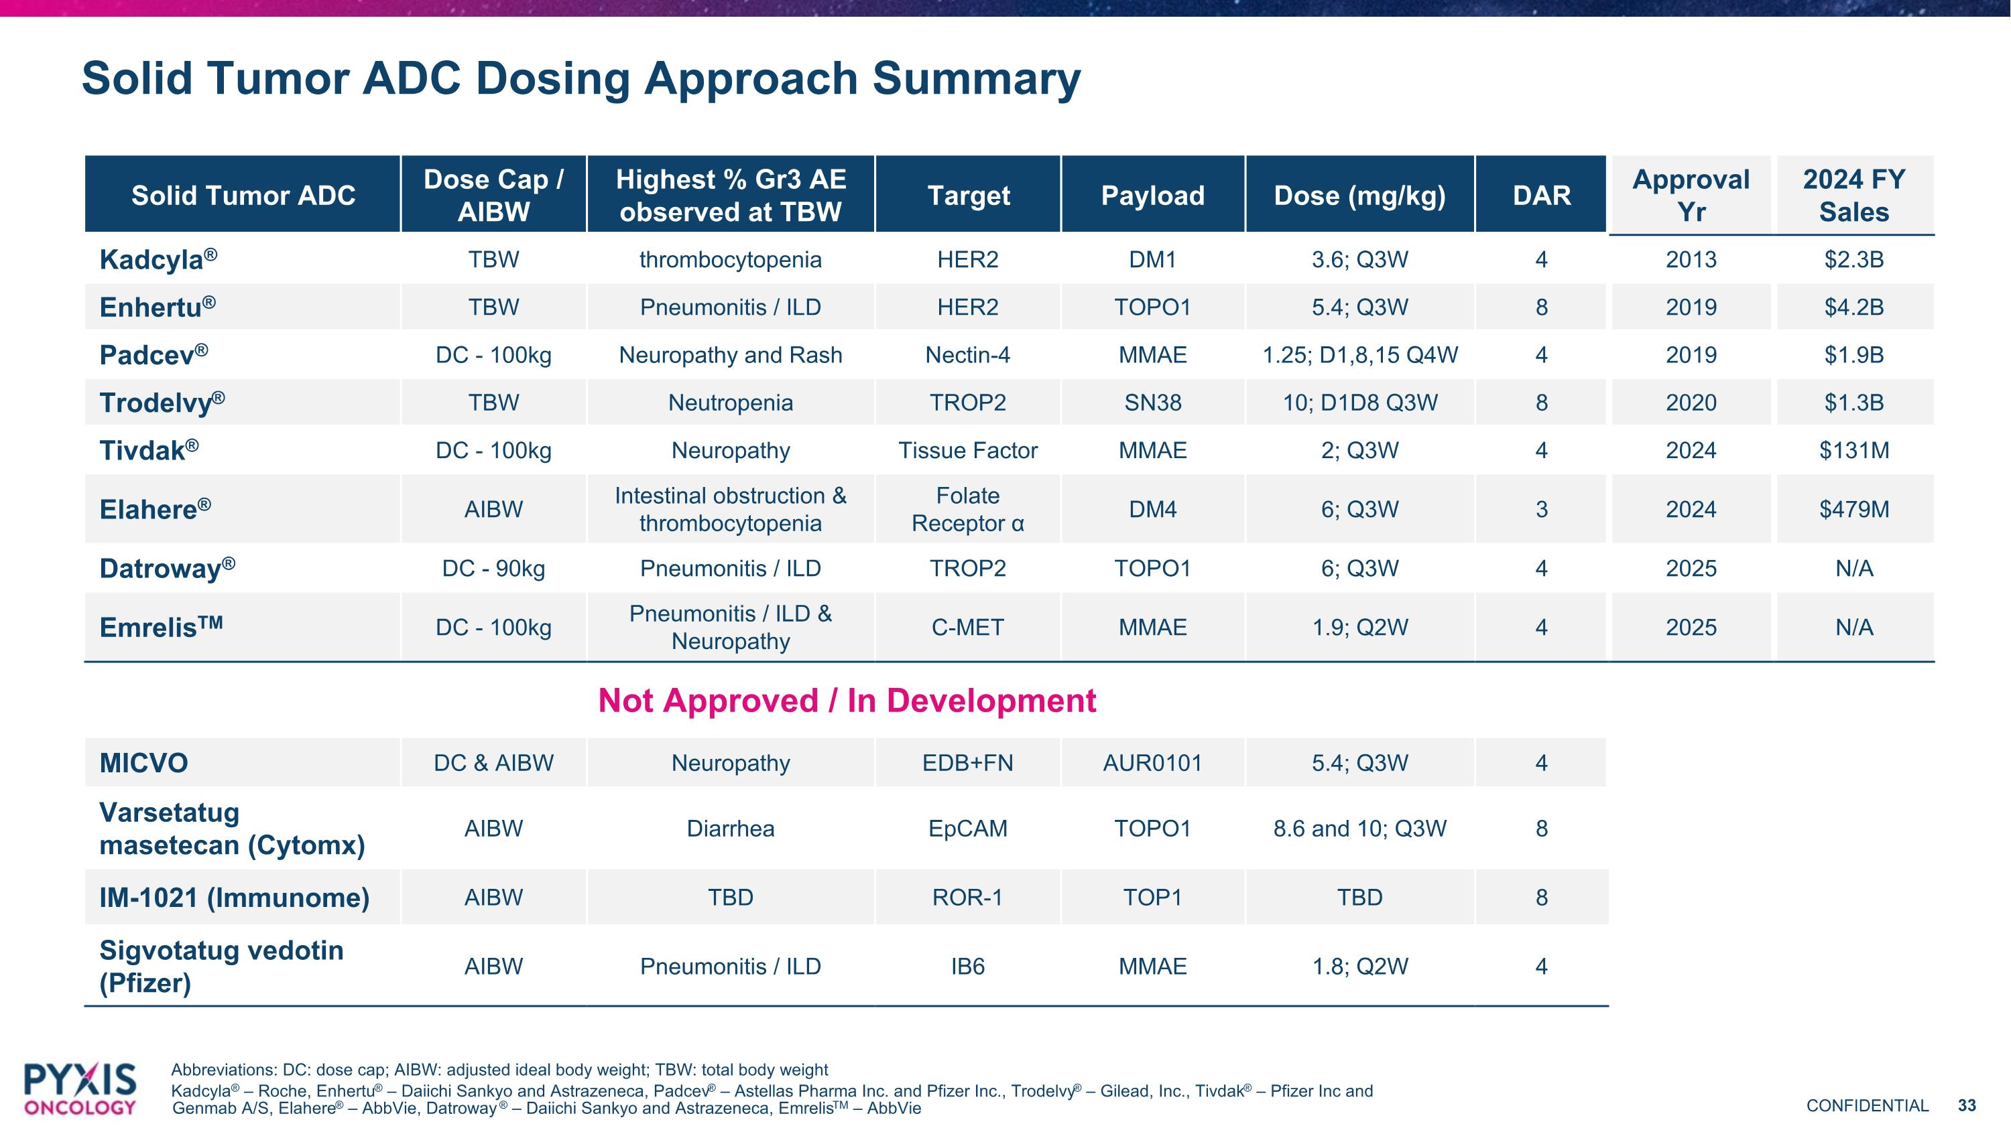
Solid Tumor ADC Dosing Approach Summary Abbreviations: DC: dose cap; AIBW: adjusted ideal body weight; TBW: total body weight Kadcyla® – Roche, Enhertu® – Daiichi Sankyo and Astrazeneca, Padcev® – Astellas Pharma Inc. and Pfizer Inc., Trodelvy® – Gilead, Inc., Tivdak® – Pfizer Inc and Genmab A/S, Elahere® – AbbVie, Datroway ® – Daiichi Sankyo and Astrazeneca, EmrelisTM – AbbVie Solid Tumor ADC Dose Cap / AIBW Highest % Gr3 AE observed at TBW Target Payload Dose (mg/kg) DAR Approval Yr 2024 FY Sales Kadcyla® TBW thrombocytopenia HER2 DM1 3.6; Q3W 4 2013 $2.3B Enhertu® TBW Pneumonitis / ILD HER2 TOPO1 5.4; Q3W 8 2019 $4.2B Padcev® DC - 100kg Neuropathy and Rash Nectin-4 MMAE 1.25; D1,8,15 Q4W 4 2019 $1.9B Trodelvy® TBW Neutropenia TROP2 SN38 10; D1D8 Q3W 8 2020 $1.3B Tivdak® DC - 100kg Neuropathy Tissue Factor MMAE 2; Q3W 4 2024 $131M Elahere® AIBW Intestinal obstruction & thrombocytopenia Folate Receptor α DM4 6; Q3W 3 2024 $479M Datroway® DC - 90kg Pneumonitis / ILD TROP2 TOPO1 6; Q3W 4 2025 N/A EmrelisTM DC - 100kg Pneumonitis / ILD & Neuropathy C-MET MMAE 1.9; Q2W 4 2025 N/A Not Approved / In Development MICVO DC & AIBW Neuropathy EDB+FN AUR0101 5.4; Q3W 4 Varsetatug masetecan (Cytomx) AIBW Diarrhea EpCAM TOPO1 8.6 and 10; Q3W 8 IM-1021 (Immunome) AIBW TBD ROR-1 TOP1 TBD 8 Sigvotatug vedotin (Pfizer) AIBW Pneumonitis / ILD IB6 MMAE 1.8; Q2W 4

